1. 

2017/10/23

ITRW 324

Final Report:

Group 9:

1. Brendan Amato 26426358
2. Keagan du Toit 26117967
3. Theunnis Janse van Rensburg 25911864
4. Dahee Kim 25920057
5. Vorster Naudé 26192349
6. Zander van Vuuren 24678317
7. Philip Venter 24674672

**Part A**

**Technical Report**

**Technical Report for RIP**

**(Registered Intellectual Property)**

For ITRW 324 Blockchain Project in Information Technology and Computer Sciences

Presented by



First Edition

2017

© Abstract 2017

Abstract

This report provides a guideline for the audience – both non-technical and technical, for using the program and application of RIP (Registered Intellectual Property), for organisational and/or personal usage. For this report, the main target market is aimed at non-technical readers. The purpose of this report is to provide the users with a descriptive discussion of the main elements of RIP and the potentials thereof. The main importance of RIP consists of the usage of blockchain technologies, which make the whole experience of the application much safer than other competing applications on the market. This guide concludes with an overall summary.

This report is dedicated to non-technical readers (citizens, artists, armatures) with an ambition, and to technical readers (companies e.g. managers) who may sponsor, or assist the application in the future.

Acknowledgements

The authors (Abstract) would like to thank Pieter Rossouw for providing professional tips and assistance and to Zander Labuschagne for assisting and supervising the project at all times.

Table of Contents

Abstract i

Acknowledgements i

Table of Contents ii

Table of Figures iv

Table of Tables iv

1. Introduction 1

2. Background Theory 1

3. Literature Review 2

3.1 Design Procedure 2

3.1.1 Problem 2

3.1.2 Solution and Project Description 2

3.1.3 Specification 3

1 Hardware 3

2 Software 3

3.1.4 Optimisation 3

3.1.5 Data structure 4

4 Feasibility Analysis 5

4.1. Operational Feasibility 5

4.1.1 Performance 5

4.1.2 Information 5

4.1.3 Economics 5

4.1.4 Control/ Security 5

4.1.5 Efficiency 5

4.1.6 Services 5

4.2. Cultural/ Political Feasibility 6

4.3. Technical Feasibility 6

4.4. Schedule Feasibility 6

4.5. Economic Feasibility 6

4.6. Legal Feasibility 6

5. Presentation of Procedure 7

5.1 Hypothesis 7

5.2 Planning 7

5.3 Procedures and Code implementations 7

5.3.1 Code Implementations: Cryptocurrency 8

To create a contract and to give the creator (registering user) all initial coins: 8

To destroy coins when a transaction failure occurs: 8

To send coins to the sellers (buying process): 9

5.3.2 Code Implementations: Upload and Download music files 9

Codes used for uploading a complete album of music 9

Codes used for download music 10

5.3.3 Code Implementations: Purchase music - wallet 11

5.3.4 Code Implementations: Stream Music 11

5.4 Motivation 12

6. Ways of Measuring Performance 12

6.1 Personal Observation 12

6.2 Oral Reports 12

6.3 Written Reports 12

7. Results and Findings 12

7.1 Prototype Testing 12

7.1.2 Website 13

Home Screen 13

Artists Screen 13

Album Screen 14

Search Result 14

Top Artists 15

7.1.3 Mobile Application 16

Login Screen 16

Register Screen 16

Forgot Password Screen 16

Music Brower Screen 16

Navigation Drawer 17

Music player Screen 17

Edit Profile Screen 17

About Screen 18

My Playlist Screen 18

7.2 Result 18

8. Conclusion 19

9. Bibliography 20

Table of Figures

Figure 1: Data structure of RIP 4

Figure 2: Gantt Chart implemented for time management 6

Figure 3: Code - cryptocurrency (give coins): 8

Figure 4: Code - cryptocurrency (transaction failure solutions) 8

Figure 5: Code - cryptocurrency (sending of coins) 9

Figure 6: Code - upload music 10

Figure 7: Code - download music 10

Figure 8: Code - wallet 11

Figure 9: Code - stream music 11

Figure 10: Prototype (web site) - home screen 13

Figure 11: Prototype (web site) - artists screen 13

Figure 12: Prototype (web site) - album screen 14

Figure 13: Prototype (web site) - search result 14

Figure 14: Prototype (web site) - top artists 15

Figure 15: Prototype (web site) - top albums 15

Figure 16: Prototype (mobile) – login 16

Figure 17: Prototype (mobile) - register 16

Figure 18: Prototype (mobile) - forgot password 17

Figure 19: Prototype (mobile) - music browser 17

Figure 20: Prototype (mobile) – navigation 17

Figure 21: Prototype (mobile) - music player 17

Figure 22: Prototype (mobile) – edit user profile 18

Figure 23: Prototype (mobile) – about 18

Figure 24: Prototype (mobile) – my playlist 18

Table of Tables

Table 1: application used for developement 7

1. Introduction

The majority of artists, whether it be in music, artworks, or filmography at some point have encountered a copyright violation issue. Most of these issues consists of illegal distribution or the misuse of the artists’ artwork without their permission/consent. To combat this problem, Abstract aims to provide the users – in this case the artists - with a secure website and application with blockchchain technology. Blockchain in broad terms is referred to the decentralised digital ledger which is recorded in cryptocurrency and stored in a chronological order (Swan, 2015:02-03). In other words, it is a technology that reduces the need for third-parties to manage transactions between two of more users as multiple people across the globe will be managing that specific transaction (e.g. the purchase of music). A key element to blockchain is distribution and decentralisation – since there are no centralised company/individual managing the transaction, it is near impossible for someone to corrupt the network. RIP (Registered Intellectual Property) makes use of this blockchain technology which results in a secure and trustworthy application. The objective of this report is to portray the potentials and strongly recommend RIP towards the digital artists. This report contains the: background theory, literature review, procedures, results of RIP, and concludes with a strong positive impact of RIP. For the purpose of this report, user are indicated as “artists”, however, the main focus of the users are aimed at musicians.

1. Background Theory

Blockchain is a relevantly new concept to the digital society - it was been around for a mere decade. According to King and Nadal (2012:1-4), blockchain made its first appearance in 2008 when Satoshi Nakamoto implemented blockchain into Bitcoin. Bitcoin is decentralised electronic currency that uses peer-to-peer technology as well as cryptography - which is used to make payments/ transactions for goods and services (Kroll, *et al*., 2013:1-2). Bitcoin is available in 18 different currencies and is used all around the world. The reason to why Bitcoin became popular in comparison with other cryptographically digital currencies is not only for the fact the Bitcoin has a far superior security, but also for their economic soundness. Bitcoin (or blockchain enabled Bitcoin), had its downfalls in the beginning of implementation and is still continuing today. There are many users that feel unsecure of the whole concept of blockchain, however, according to Ateniese *et al*. (2017:111-127), Bitcoin’s value (price) has risen to $4000 (when the report was compiled) and sees no trend of falling but doubling at a very rapid pace.

RIP implements this blockchain technology and thus, also can predict a positive worthiness. Unfortunately, as blockchain is such a new concept, Abstract had no prior knowledge or preparation of it, nor of any web/app development. However, Abstract has successfully learnt and implemented these technologies thereof.

1. Literature Review

Before continuing reading with this report, it is important to note that this report is targeted to potential artists who would avoid being victims of copyright policies from other people. RIP is currently focusing on the younger generation population who are more familiar with the internet and digital currencies, however, Abstract would like to encourage all ages to make use of RIP.

The SMART analysis has been made, before the design procedure was planned. Specifically – Abstract planned to create a software that allows artists to sell their products online in a more secure manner as well as to allow the users to track their artworks that have been distributed illegally. Measurable – the project will be measured via meetings held frequently. Achievable – the challenges that the group may have encountered consists of trial periods expirations that may occur for external sourcing e.g. GitKraken or for the need in purchasing them. However, these issues can be resolved by using “student pro” versions or with the assistance from NWU. Relevant/ realistic – the goals for our project is to provide a user-friendly software that allows end users (digital artist) to expand their careers by distributing their artworks in a more secure and trustworthy application; these goals are possible to attain through the use of external sources such as Webstorm etc. Timely – the group was given roughly four months to create the project and the group also made use of peer assessment for time management. With the SMART analysis stated, the design procedures can be discussed.

# Design Procedure

## Problem

From the End user’s (artists’) perspectives, copyright infringement has always been and will be problematic. According to the Copyright Act (98 of 1978) of South Africa, violations of the Copyright Act includes the unlawful use of: literacy or musical works, sound recordings, cinematographic films, artistic works, drawings, etc. Also, that these works can only be distributed in respectful manner whereby the copyright holder should be made known of any distributions/ sales, and all items must be traded fairly. Many artists have experienced a situation whereby an individual/ company used their work without their consent. Examples of theses situation can be when a company uses a piece of music for their official promotional videos or uses a stock photo from artists and earns profit out of them. Not only did the culprit steal the digital asset, they also steal possible income of the artists. It is important to keep in mind that most of these artists are either hobbyists, amateurs, or small businesses who rely on every bit of income. It is clear that these artists want a secure site that can not only manage their financial transactions safely, but also prevent the culprits from misusing their digital assets/ artworks.

## Solution and Project Description

With the problems stated, it is clear that some platform of service is needed to assist these artists. Abstract has come up with an idea that solves these copyright issues and problems by creating an application. However, in order assist as many artist as possible at the same time, a networking technology is required; thus, Abstract decided on using the Internet. With the use of the Internet, not only will the artists easily access the application from all across the globe, but the artists can save up money as these artist do not need to pay professional third parties to manage their goods/services.

The idea of the application was to firstly to manage the music and other digital assets by making use of blockchain technology. The users can then access the application through a website (web service) or mobile application. Thus, Abstract visualised on an application called RIP (Registered Intellectual Property).

## Specification

### Hardware

Hardware specifications needed by the users consists of a personal computer (Mac is also accepted) which has connection to the internet. Internet speed should be above 1.5Mbps to prevent any buffering and frustrating experiences. It is also suggested that users use monitor screen resolutions of 15.6 inches for maximum comfort (however, other sizes do work too). As for the mobile application, a smart phone is required. A screen resolution of 5 to 5.5 inches is recommended for the most comfortable view and experience.

### Software

Software specifications needed by the users consist of a personal computer that runs on either Windows or Max OS X which has a preinstalled web browser e.g. Google Chrome or Mozilla Firefox (avoid using Internet Explorer as it may cause the website to become slower). As for the mobile application, users should have an Android OS with an API level of 21+ and above, namely: Lollipop, Marshmallow, Nougat, and Oreo. Thereafter users should download and install the RIP application onto their mobile phones.

## Optimisation

RIP strives to optimise the users’ efforts by reducing the stressful process to hire third-parties for management as well as copyright violation. Fortunately for the users, RIP is currently a freeware. Users do not have to pay to use the application (both web and mobile). However, it is important to keep in mind that the digital assets made available through RIP may be paid for - depending on the copyright holder. With a purpose to keep the cost of RIP down, Abstract had made use of other freeware available on the internet or have made use of trial versions in the development phase. There were some cases whereby the group had to purchase a licence or class fee, however, these costs has been kept to a minimum by the uses of discounts and student privileges. RIP is also an easy-access, easy-to-join, and simple application. Not only is the application user-friendly, it is also self-explanatory. RIP reduces time and money spent by artist by providing efficient transaction processes, music streaming and hosting, and more.

## Data structure

The following figure indicates the database data structure that has been implemented to optimise the database flows effectively.

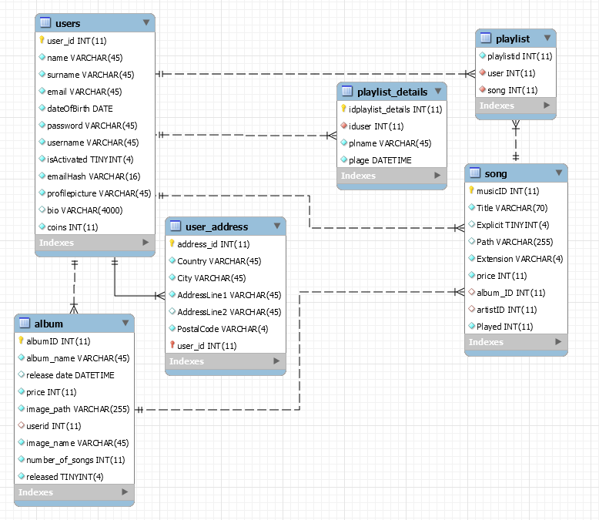

Figure 1: Data structure of RIP

1. Feasibility Analysis

To analyse the feasibility of the project (how worthy is the project), six tests has been considered.

# Operational Feasibility

Operational Feasibility focuses on how well the RIP solves the problem of copyright violations. As discussed above, RIP has been designed to solve these copyright issues from the very beginning. Operational feasibility adds value and improves the quality of the system. It bridges any flaws in the system and makes the: performance, information, economics, security, efficiency, and service improvements towards the system. To further discuss operational feasibility, the PIECES framework is used.

## Performance

* Simplifies transactions
* Simplifies processes of digital asset sales
* Improves overall experience of music streaming, and asset uploading.
* Increased opportunity to introduce product on a global scale.
* Simplifies the tracking process.
* Simplifies copyright policies for own works.

## Information

* Information regarding the copyright holder’s private data is kept confidential
* Data is stored on MySQL – an efficient database management system.
* Input from users is easy and uncomplicated.

## Economics

* Users (artist) do not have to pay third parties for external management
* Users do not have to pay to use RIP
* Artworks are sold via cryptocurrency making transactions safer.
* May attract potential customers – boosts sales.

## Control/ Security

* RIP uses blockchain-enabled high-level cryptocurrency.
* Easier for users to control who is the culprit behind “stolen art”.
* Personal information is kept confidential

## Efficiency

* User-friendliness
* Interactive system
* Accessible from multiple platforms/ devices

## Services

* Notifies user when error occurs.
* Customer service is effective.
* Faster services increases customer satisfaction.

# Cultural/ Political Feasibility

RIP aims to satisfy all organisational climates. RIP is dedicated to artists who have already been victims to copyright violations. It is unavoidable that there may be user who are uneasy to the application as the concept of digital currency (blockchain) is relevantly new and some may still feel unsafe using this type of system. However, as RIP is a casual application, users are not required to change their personal environments but can access it from their comfortable locations.

# Technical Feasibility

The project meets the technical feasibility positively as the proposed solution is highly practical in reality. All necessary technologies required for the project is attainable through the internet and from alliance companies such as Amazon for Web Services. With regards to whether Abstract possesses the necessary technical expertise, members have been taking online classes and have been researching about the project privately. Also, members have had assistance from supervisors.

# Schedule Feasibility

As mentioned above, Abstract has been given roughly four months and had a planning as the Gantt chart shows, in figure below.

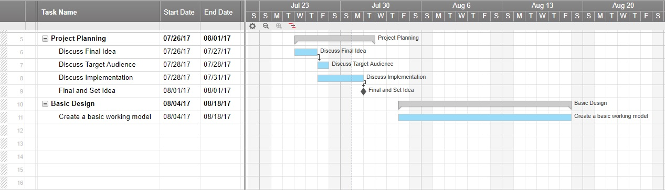

Figure 2: Gantt chart implemented for time management

It has been made aware that if Abstract were to miss the deadlines of the project, then members would take responsibility and accept the penalties thereof.

# Economic Feasibility

Economic feasibility measures the cost effectiveness of the project solution. This section will be discussed in detail under cost/benefit analysis in Part B of the report.

# Legal Feasibility

With regards to legal feasibility, RIP has been developed to assist and improve the matter. RIP has been created by all legal functionalities, and abides and respects the software laws. As RIP is a private application (owned by Abstract), RIP need no Union Contracts with other client companies, nor individuals. The main purpose of RIP is to protect the Copyright Act 98 of 1978, and prevent any further violations of the act.

1. Presentation of Procedure

# Hypothesis

RIP will reduce the number of victims (artists) on copyright violations and carry out securer transactions for payments of digital assets.

# Planning

To work collaboratively, Abstract made use of a git software called GitKraken. GitKraken allows several users to collaborate with each other on a same project at the same time. In a more common sense, one can push (upload) their work onto a branch (similar to a sub-folder) onto a network and also pull the contents (download newly added contents to that subfolder by another member). Abstract made use of seven branches namely: develop, Feature (folder), mobile app, truffle, web service, website, document, and master. By doing so, member were able of focusing on a specific feature, either to develop or test it and by splitting the branches, overwriting other member’s work was avoided. For the process of testing the RIP application, Abstract kept performing mini-prototypes (testing parallel to coding). Other methods included tests made by other group members and tests from different devices. It was planned that different applications are to be used for different features. These features include, websites, web services, and mobile applications – with blockchain. This point will be further discussed later on in the report. Abstract’s decision analysis solution concluded in creating a new computerised software.

One of the goals of the project was to keep the cost at minimum while keeping the efficiency at maximum. Preventing and counteracting unknown or possible errors were planned so that whoever encounters the error, must firstly report to the group messaging chat (Discord), and then either solve it: themselves, ask for assistance and pair up, or ask the demi for assistance.

# Procedures and Code implementations

Before the procedure is discussed, the following applications has been used for the project:

|  |  |
| --- | --- |
| Application Name | Field/ Purpose |
| Node.js | Web service – used for the generation/ creation of the webserver |
| Atom IDE | Web service – editing the codes of Node.js |
| Postman | Web service – testing the web service |
| Webstorm | Web site – used for website development |
| Google Chrome | Web site – testing of website |
| Android Studio | Mobile Application – development of app |
| MySQL | SQL – used for all databases |
| GitHub | Git – used for git technologies and store/share repos |
| GitKraken | Git – used for version control |
| Discord | Communication – served as the main communication medium |
| Slack | Communication – used for git updates and backup important messages |
| WhatsApp | Communication – used for personal/ comfortable messages or reminders |
| Truffle Framework | Ethereum – used for cryptocurrency payment engine and frameworks the blockchain used |
| Amazon Web Service | Cloud – used especially for mobile application’s cloud. Also hosts database and web service on an instance. |

Table 1: application used for developement

The first step was to ensure that all the Abstract member were connected to the group chat on Discord. The reason why Abstract selected Discord for communications was for the easy use of group calls and user-friendliness. All members had to connect to GitHub and all other accounts for collaboration. Then the web server was hosted, allowing all other applications to connect to it. From here on, the members spilt tasks (features) into pairs and worked on it thereof by using the applications mentioned in the above table.

## Code Implementations: Cryptocurrency

These were the codes that have been implemented into RIP for the main feature to buy music (artworks) using the blockchain technology. Note that only a selected few codes will be implemented in this technical report, as the target readers of this document is non-technical readers, thus this section has been dedicated to the few technical reader.

### To create a contract and to give the creator (registering user) all initial coins:

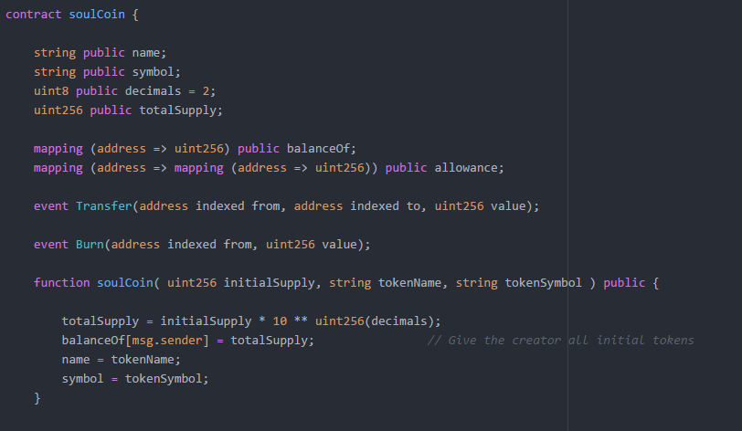

Figure 3: Code - cryptocurrency (give coins):

### To destroy coins when a transaction failure occurs:

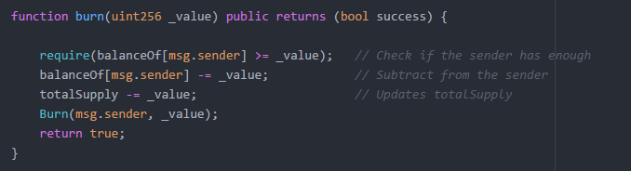

Figure 4: Code - cryptocurrency (transaction failure solutions)

### To send coins to the sellers (buying process):

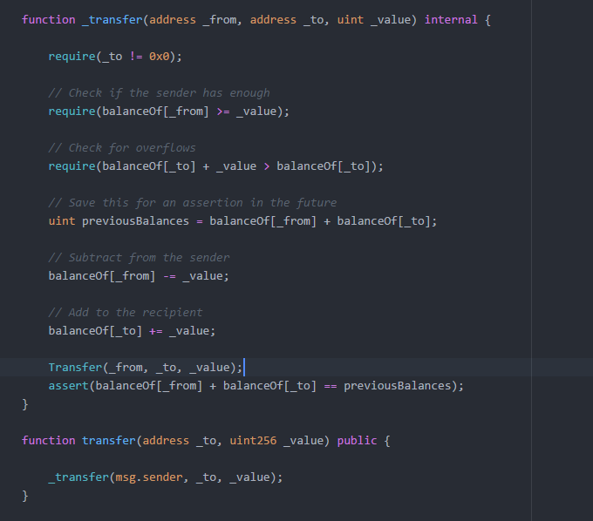

Figure 5: Code - cryptocurrency (sending of coins)

## Code Implementations: Upload and Download music files

### Codes used for uploading a complete album of music

The steps are as follow:

* 1. Create album in database and return the primary key
  2. Use the primary key of the album to upload the raw mp3 files into the server’s file system.
  3. Add the actual names and cost of each song and verify it to ensure there is no room for human error.

The raw mp3 files are then saved in the file systems and their path is stored in the database for later retrieval. The song names specified by the user are also saved in the database and linked to the each respective file path. At this point the album is not released yet. The user has to explicitly release the album to ensure no albums get published by accident. This is done by entering manage content mode and clicking the release button that will be present on all albums that have not yet been released.

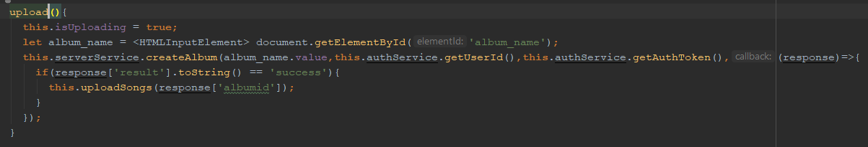

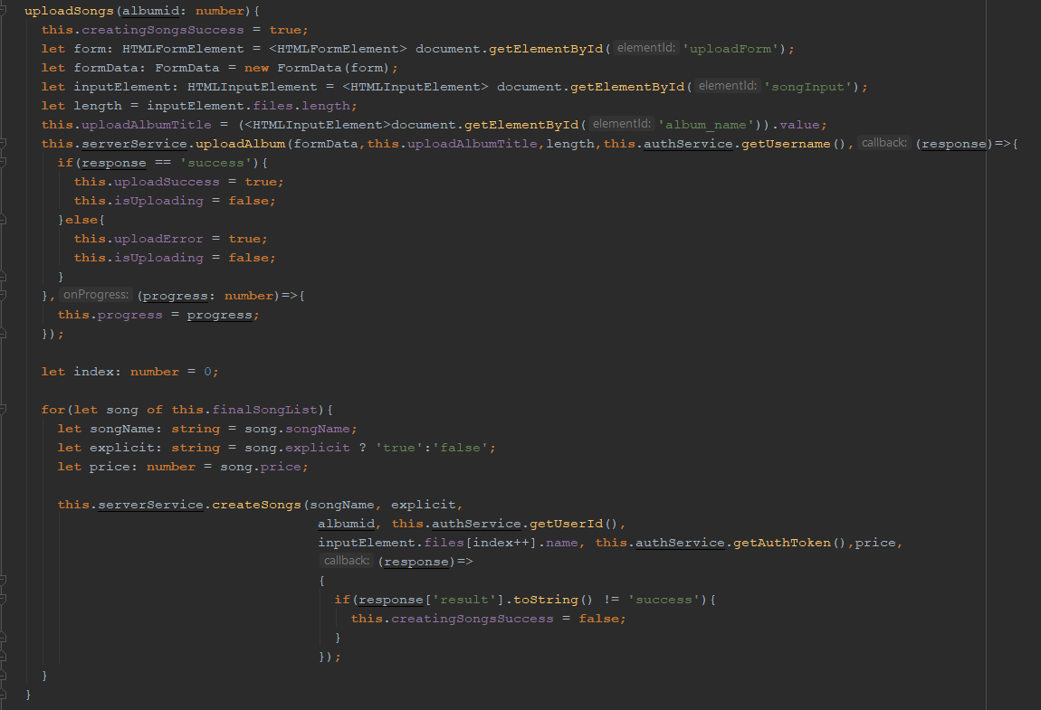

Figure 6: Code - upload music

### Codes used for download music

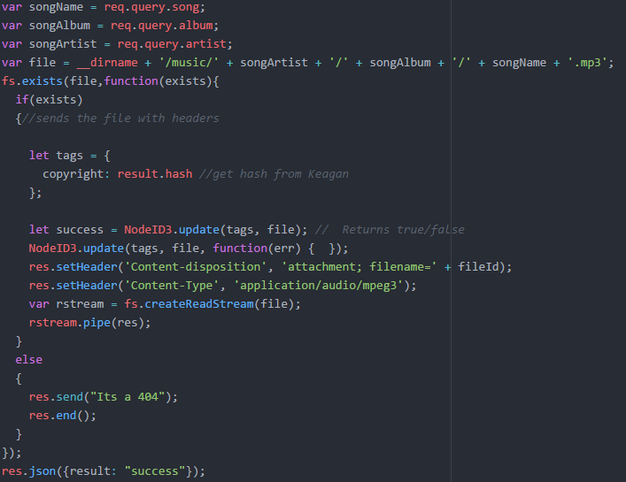

Figure 7: Code - download music

## Code Implementations: Purchase music - wallet

The wallet component handles all transactions and shows the user his/her balance. The balance is shown as an amount of coins as well as the amount of songs the user can buy with the current balance. Since the currency’s buying power may vary, the amount of songs the user can buy is a much better indicator of how much the user actually has than the amount of coins. The wallet also shows the average cost of a song and the average cost of an album.

A small version of the wallet also runs in the website’s navigation bar to ensure that the user always knows his/her balance. It is indicated with a number and a logo containing an orange coin and a soul ghost inside of it.

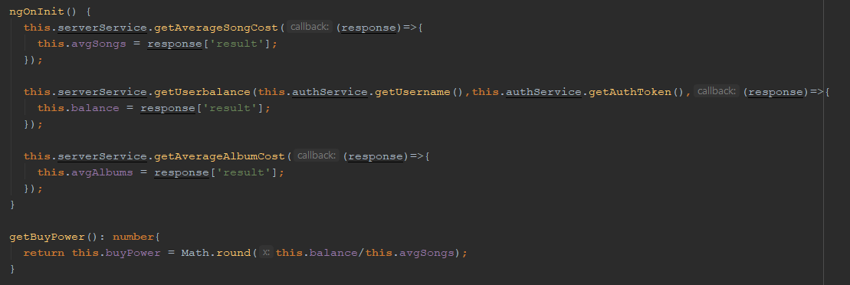

Figure 8: Code - wallet

## Code Implementations: Stream Music

Once the media player server searches for the requested song, streams the music if the token given is valid

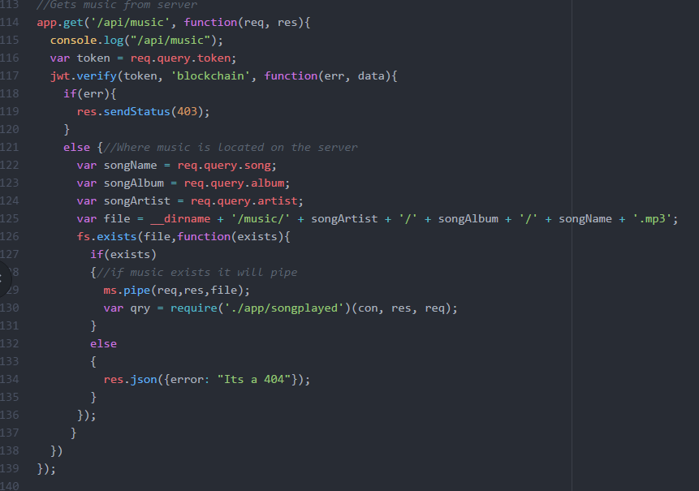

Figure 9: Code - stream music

# Motivation

In simple terms, Abstract desired to provide a pleasing environment for artists from all places with a wide range of interests in digital entertainment. The members were motivated to create this project as the member were all fond of copyright violations and several member were also a hobbyist themselves. Abstract ware requested to complete this project within the given due-date.

1. Ways of Measuring Performance

# Personal Observation

Through simple observation, it was clear to keep track of the application’s functionality in practise. RIP provided a user-friendly, easy to use, and easily accessible platform for the users.

# Oral Reports

Complaints and compliments of RIP applications were given feedback in an oral communication method such as customer care service; and was dealt swiftly by Abstract members.

# Written Reports

Written reports consisted of mainly commentary messages and ratings. Users provided Abstract with casual commentary. Overall performance and comments had a positive feedback.

1. Results and Findings

# Prototype Testing

Discovery Prototyping was used to see the reactions of the users as well as to see the overall experience of RIP. It was also used to verify the requirements and improvements thereof. It was made clear that since this was a prototype, the system was incomplete and emphasized that the ultimate program may appear different and have more/less functionalities.

## Website

### Home Screen

From the home screen, user can click on a song name which will automatically start playing in the music footer. The user can click on the artist name to navigate to the specific artist’s page.

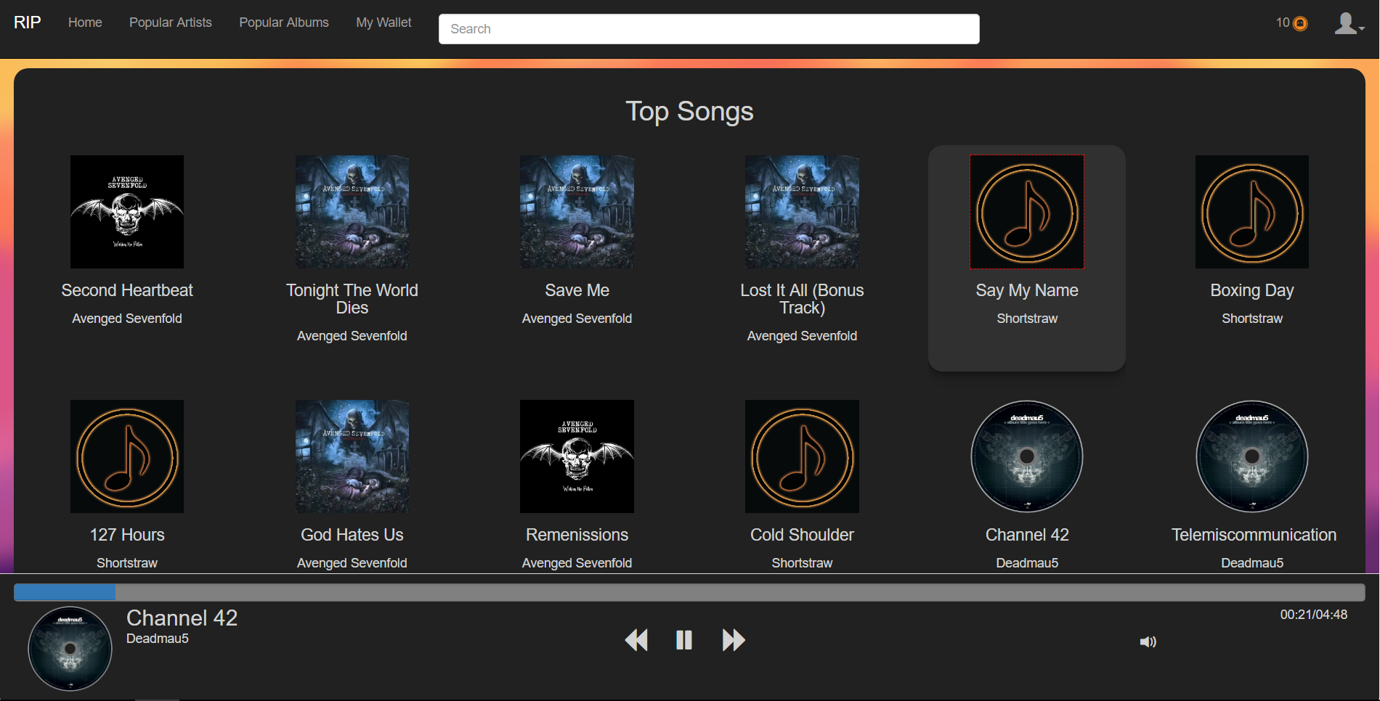

Figure 10: Prototype (web site) - home screen

### Artists Screen

User can see an artist’s album and their biography.

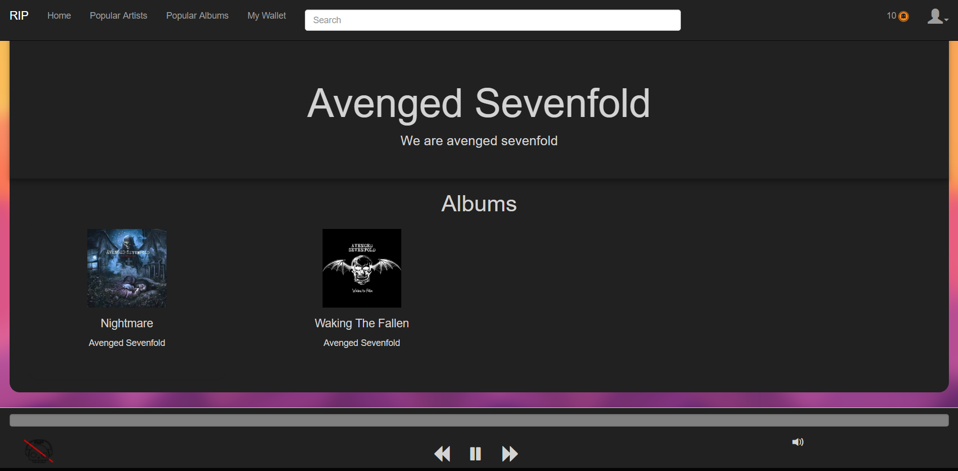

Figure 11: Prototype (web site) - artists screen

### Album Screen

When artists selects on an album, the following is displayed. Users can buy a specific music from this select.

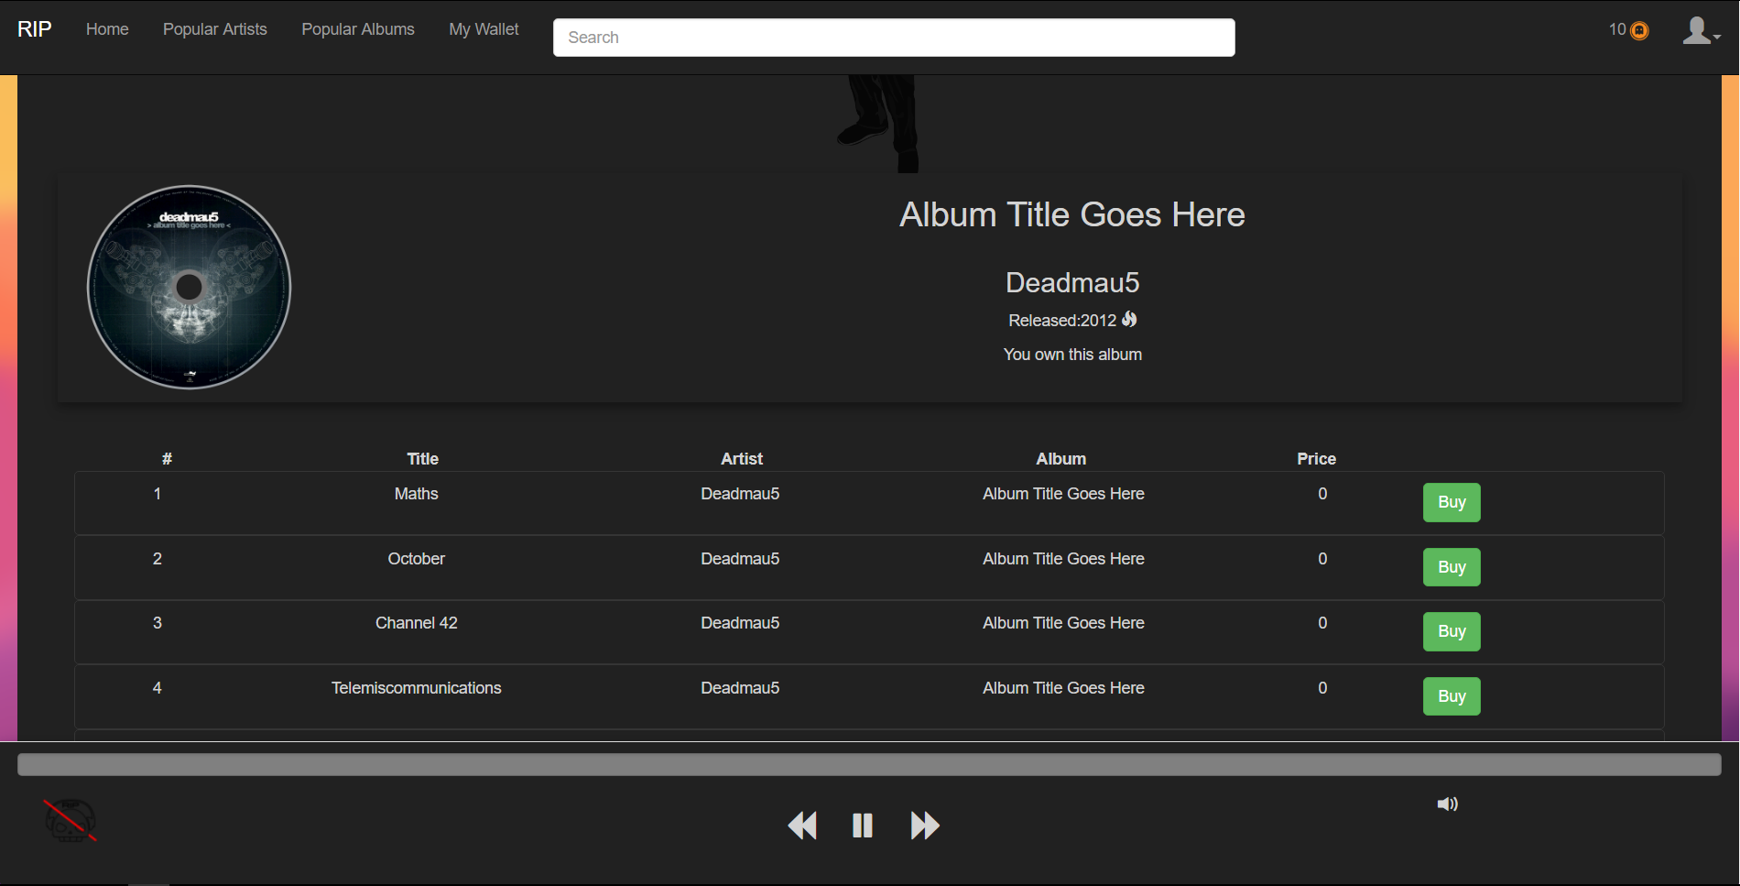

Figure 12: Prototype (web site) - album screen

### Search Result

When users search for a music in the search bar, music with similar search keys are suggested.

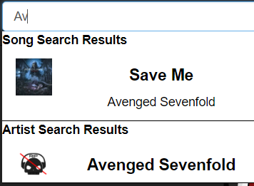

Figure 13: Prototype (web site) - search result

### Top Artists

Users are also provided with the top artist and top albums that have been popular for some time or the most recent music that has been searched for.

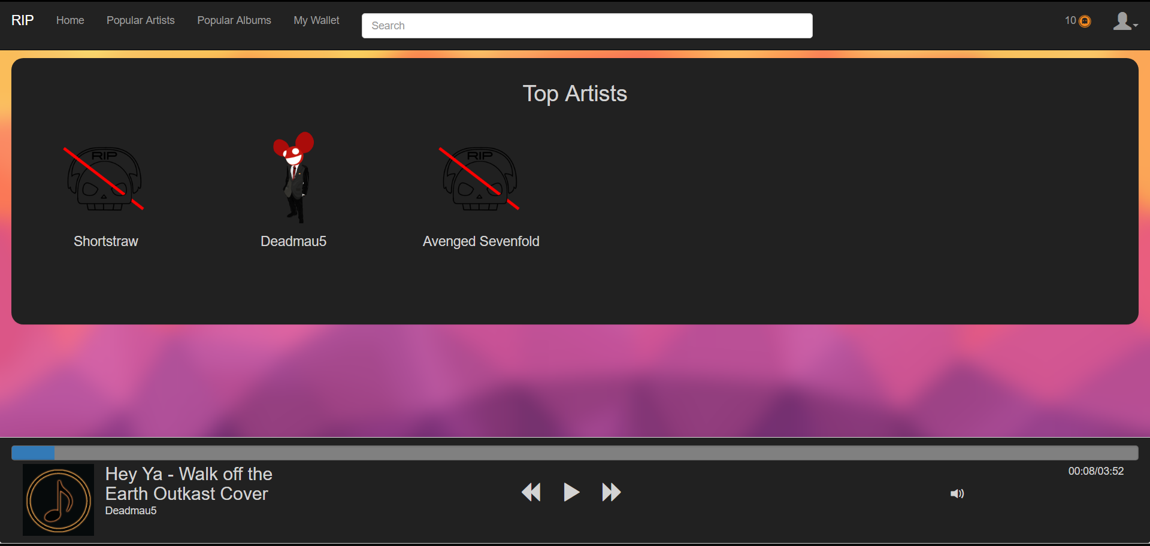

Figure 14: Prototype (web site) - top artists

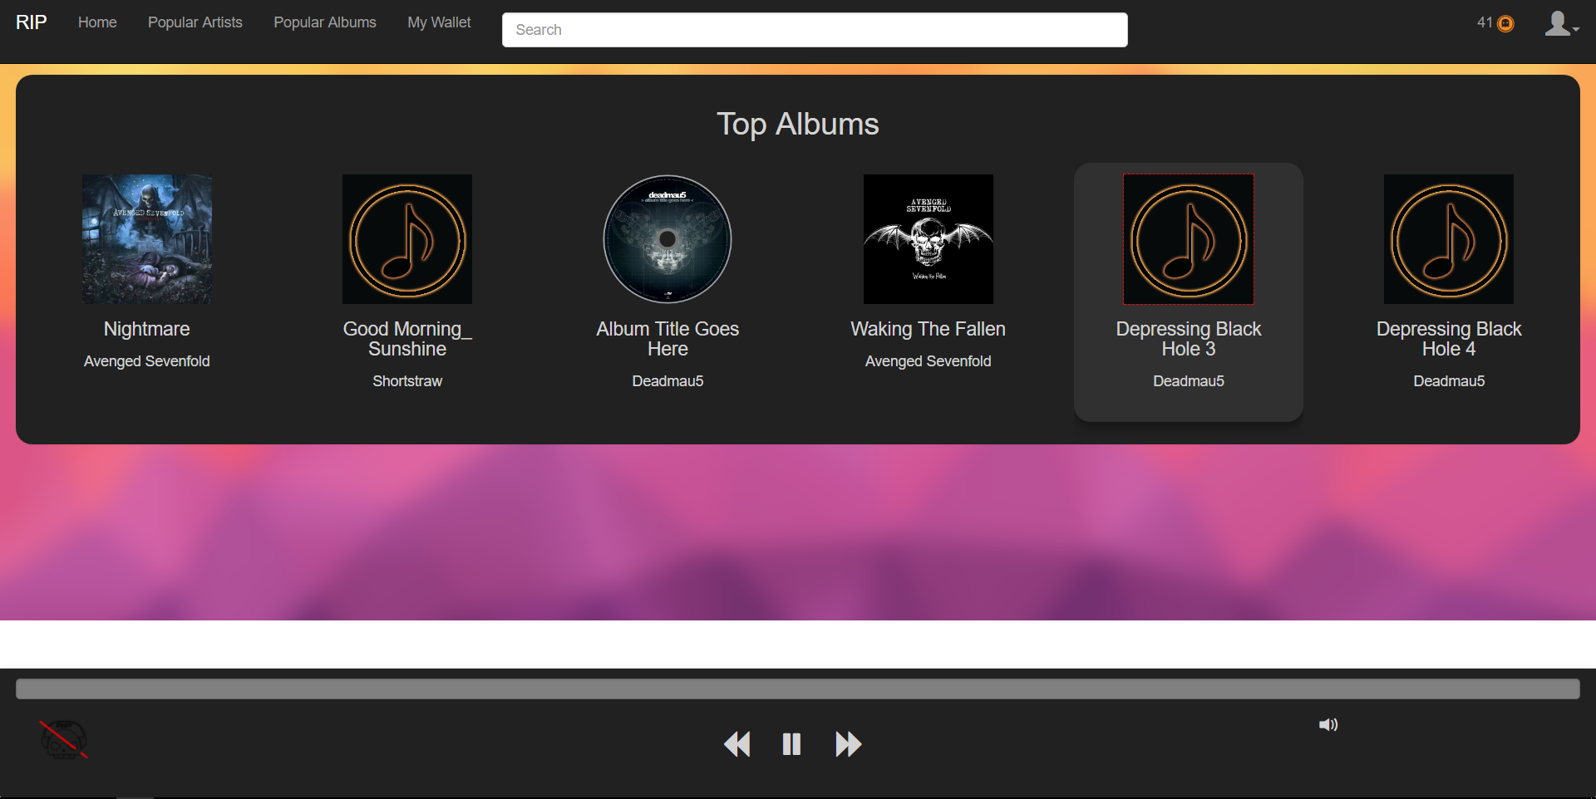

Figure 15: Prototype (web site) - top albums

## Mobile Application

The mobile version of RIP has been created with the core function of a music player. It has been decided that since mobile devices are prone to more security flaws that computer, the mobile version will function mainly as a music player. User can listen to their owned music with the application.

### Login Screen

When users open the mobile application, they will be lead to the login screen where they are required to log into the system.

### Register Screen

User can register into RIP using the Register button. Details of: personal, address, and login is required to be filled out.

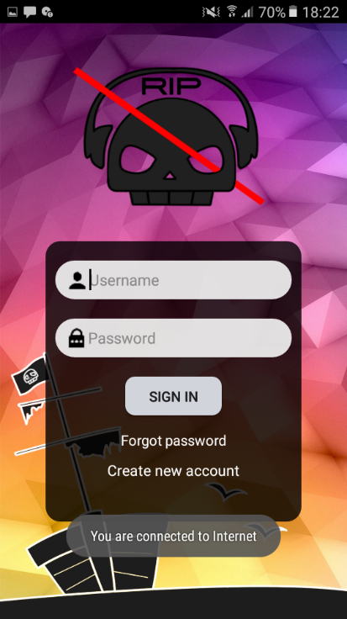 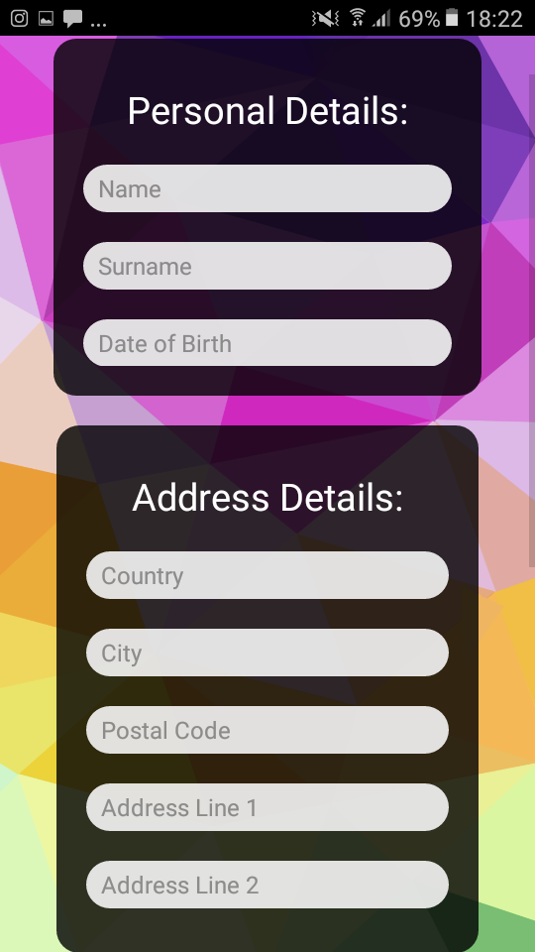 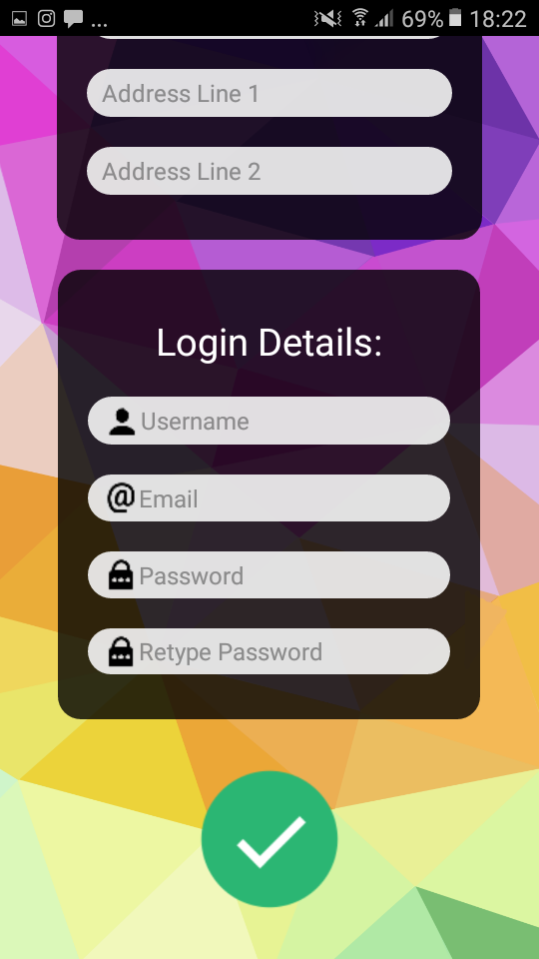

Figure 16: Prototype (mobile) – login Figure 17: Prototype (mobile) - register

### Forgot Password Screen

When users forget their password, they can change their password by receiving a verification

### Music Brower Screen

This screen is displayed once you log into the system. User can browser for the music they own and listen to them.

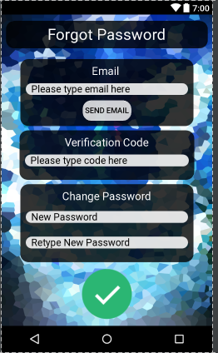 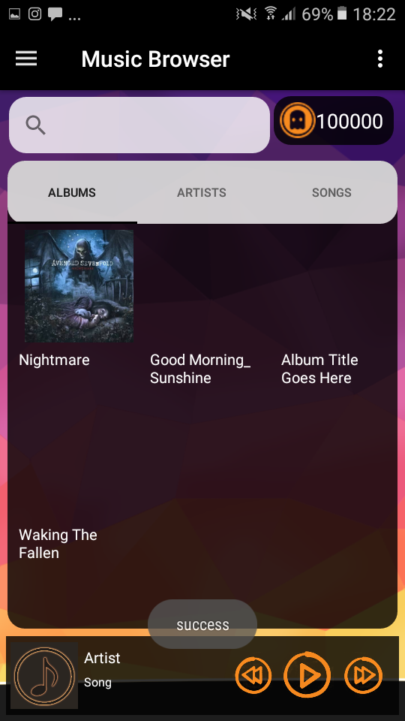

Figure 18: Prototype (mobile) - forgot password Figure 19: Prototype (mobile) - music browser

### Navigation Drawer

When users swipe right-wards on their screen the navigation drawer pops up. The navigation drawer is an easy-access menu that allows users to edit their profiles, browse music, check their playlist, check their carts, redeem their vouchers, learn about the app, and log out of the system.

### Music player Screen

The music player allows users to play the music of choice. It also displays the details of the music.

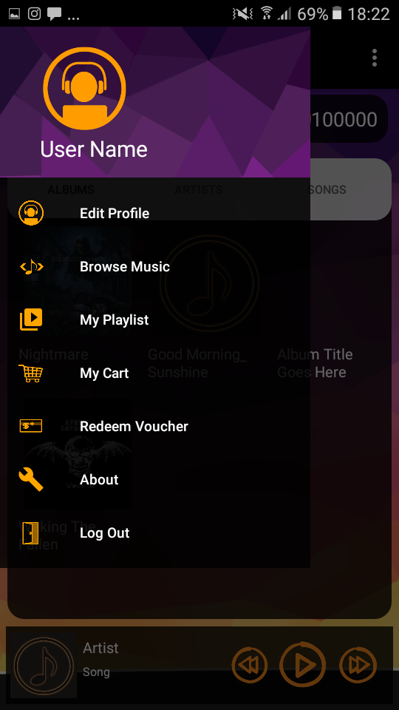 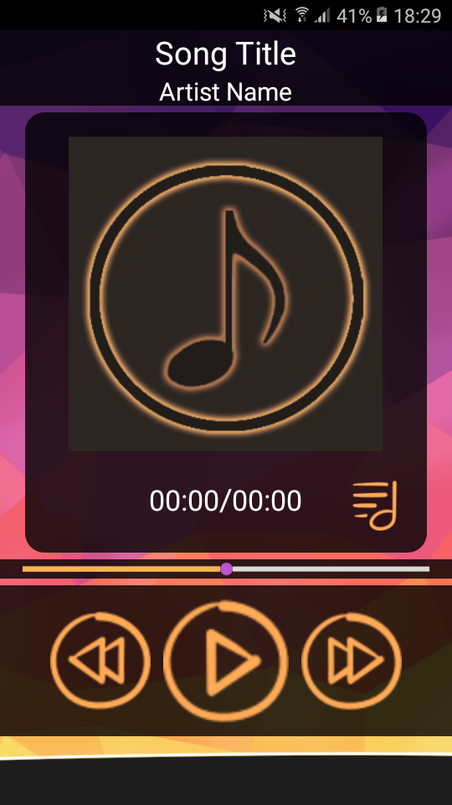

Figure 20: Prototype (mobile) – navigation  Figure 21: Prototype (mobile) - music player

### Edit Profile Screen

User can edit their personal details in this option and they can also add their own biography.

### About Screen

The users can read about RIP for interest or educational purposes.

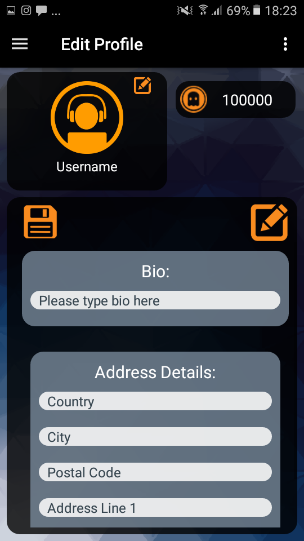 

Figure 22: Prototype (mobile) – edit user profile Figure 23: Prototype (mobile) – about

### My Playlist Screen

Users can add their favourite songs into a playlist which can be viewed in a list-format. Note that this specific playlist is empty just because the user did not add any music to it.

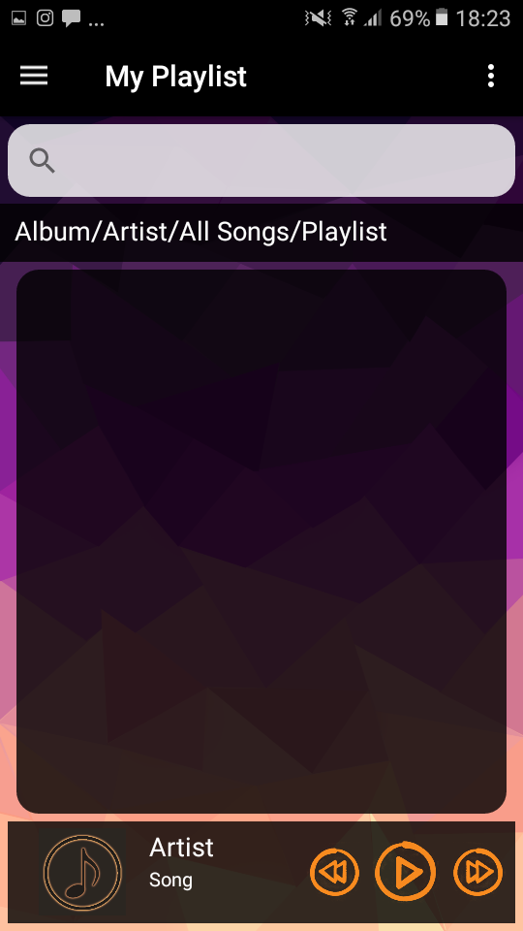

Figure 24: Prototype (mobile) – my playlist

# Result

The prototype resulted in a successful achievement of the objectives and goals. There were some bugs and glitches in the prototype, however, the purpose of the prototype was to search for these issues and see the overall running of the application in a real scenario. These issues have been later dealt by and fixed. Users of the application seemed satisfied and had a pleasant experience. Minor complaints and comments where provided by the users which were scrutinised and decided to either discard or to implement. It was also found that 70% of the users were male and the rest of the 30% users were females – using this demographics, it is possible to adjust the application towards trends at a later stage of implementation. Furthermore many users had no issues with navigating through the applications as the GUIs were user-friendly and easy to understand. Therefore, it can be stated that the hypothesis was sound.

1. Conclusion

Many artists have encountered a copyright violation issue especially in the digital realm. To combat this issue, Abstract has created an application called RIP, that uses a blockchain implemented technology which allows users (artists) to make safe financial transactions and tracking of illegal digital asset distributions. The objective of this report was to portray the potentials and strongly recommend RIP towards these digital artists. This report discussed the: background theory, literature review, procedures, and results of RIP; which has all been met. It was also found that the hypothesis was correct and sound. RIP has a high-level potential and provides a vast number of opportunities for the artists, therefore RIP is highly recommended towards artist and investors in this digital artwork industry.

1. Bibliography

Ateniese, G., Magri, B., Venturi, D. and Andrade, E., 2017. Redactable blockchain–or–rewriting history in bitcoin and friends, *Security and Privacy (EuroS&P), 2017 IEEE European Symposium.*  (2017)111-126.

King, S. and Nadal, S., 2012. Ppcoin: Peer-to-peer crypto-currency with proof-of-stake. (1):1-5.

Kroll, J.A., Davey, I.C. and Felten, E.W. 2013. The economics of Bitcoin mining, or Bitcoin in the presence of adversaries, *Proceedings of WEIS. (*2013):1-2.

Nakamoto, S., 2008. Bitcoin: A peer-to-peer electronic cash system. https://bitcoin.org/bitcoin.pdf Date of Access: 3 Oct 2017.

South Africa. 1978. Copyright Act 98 of 1978.

Swan, M. 2015. Blockchain: Blueprint for a new economy. Sebastopol, California: O'Reilly Media, Inc.

**Part B**

**Business Case**

**Business Case**

**Project Name:**

RIP (Registered Intellectual Property)



**Authors**:

Abstract (Group 9)

**Sponsor**:

NWU - PUK



Presented by Abstract

First Edition

2017/10/16

© Abstract 2017

Amendment History

Contains any changes made to this report.

|  |  |  |  |
| --- | --- | --- | --- |
| **Number** | **Date** | **Author** | **Reason** |
| **1** | 22 Oct 2017 | Abstract – D. Kim | Overall Editing |

Distribution List

Contains a list of individuals who have received this document.

|  |  |
| --- | --- |
| **Name** | **Occupational Reason** |
| Z. Labuschagne | Demi |
| P. Rossouw | Lecturer |

Abbreviations

The following terms appear throughout this document.

|  |  |
| --- | --- |
| **Abbreviation/ term** | **Word** |
| CBA | Cost Benefit Analysis |
| GDP | Gross Domestic Product |
| OS | Operating system |
| RIP | Registered Intellectual Property |

Table of Contents

Amendment History i

Distribution List i

Abbreviations i

Table of Contents ii

Table of Figures iv

Table of Tables iv

1 Executive Summary 1

2 Introduction 2

3 Overall Project Description 2

3.1 Purpose and Objective 2

3.2 Approach 2

3.3 Identification of Alternative Solutions within the Project 3

3.4 Current Market Situation 3

3.5 Project Stakeholders/users 3

4. Market Analysis 3

4.1 Current state of RIP 3

4.2 Definition of Industry 4

4.3 Target Market and Statistics 4

4.4 Competition and Market Needs 5

4.5 Regulations 5

4.6 Risks and sensitivity analysis 5

4.6.1 Popularity 5

4.6.2 Monetary Worth 6

4.6.3 Competition 6

4.7. Return on Investment 6

4.8. Threats from Emerging Technologies 7

5. Cost/ Benefit Analysis 8

5.1 Quantified Analysis 8

Net Present Value 10

5.1 Unquantified analysis 10

6. Assessment of Benefits 11

7. Option Appraisal – Recommended Option 12

8. Key Assumptions and Dependencies 14

8.1 Assumptions: 14

8.1.1 A fully committed development team: 14

8.1.2 Best available development team: 14

8.1.3 RIP service times: 14

8.1.4 Flawed system/ System maintenance: 14

8.1.5 Accuracy of project schedule: 14

8.1.6 Basic knowledge of the website: 14

8.2 Assumption Prioritization: 15

8.2.1 A fully committed development team: 15

8.2.2 The best possible development team: 15

8.2.3 Accuracy of project schedule: 15

8.2.4 Flawed system/System maintenance: 15

8.2.5 RIP service times: 15

8.2.6 Basic knowledge of the website: 15

8.3 Dependencies: 15

8.3.1 Finish-to-start dependencies 16

8.3.2 Start-to-start dependencies 16

**8.3.3** **Finish-to-finish dependencies** 16

8.3.4 Start-to-Finish dependencies 17

9. Implementation Considerations 17

9.1 POET approach: 17

9.1.1 Political 17

9.1.2 Operational: 18

9.1.3 Economic/Financial: 18

Technical: 18

9.2 Concepts to understand before investing: 18

10. Resource Requirements And Cost 19

11. Funding Source/ Timing/ Certainty 19

11.1 Short-Term Funding 19

11.1.1 Overdrafts 19

11.1.2 Loans 20

11.2 Long-Term Funding 20

11.2.1 Business Angels/Investors 20

11.2.2 Retained Profits 20

12. Timescale 20

13. Comments/ Issues 21

14. Results and Findings 21

15. Conclusions and Recommendations 21

16. Bibliography 22

Table of Figures

Figure 25: most pirated digital assets 4

Figure 26: costs with implemented ROI 6

Figure 27: benefits figures 8

Figure 28: costs figures 9

Figure 29: total profits 9

Figure 30: work breakdown structure 24

Table of Tables

Table 2: exclusive summary costs 1

Table 3: optional appraisal 13

Table 4: resource requirement and costs summary 19

Table 5: timescale with milestones 20

1. Executive Summary

The project group Abstract, developed an application on a website and mobile platform that allows artist (end-users) to upload and sell their artwork (targeted at music), and track the distribution of these artworks. Market analysis was the core analysis method, and through observation and cost/benefit analysis, it was found that RIP (Registered Intellectual Property) yields many benefits to artists and investors. The key objective to this project is to prevent copyright infringements and provide a platform for amateur and hobbyists to earn an income. The key objective of this report is to convince investors and users to make use of the RIP applications.

The financial figures calculated are summarised as follows:

|  |  |  |  |  |  |  |
| --- | --- | --- | --- | --- | --- | --- |
|  | **Year 1** | **Year 2** | **Year 3** | **Year 4** | **Year 5** | **Total Cash Outlay** |
| **Capital** | $ 2 000 | $ 3 000 | $ 2 000 | $1 000 | $ 1000 | $ 9 000 |
| **Available Funding/ income** | $ 55 700 | $ 125 294 | $ 227 812 | $ 245 225 | $ 269 760 | $ 923 791 |
| **Expenses** | $ 119 375 | $ 93 051 | $ 28 988 | $ 27 950 | $ 27 935 | $ 297 299 |
| **Return on Investment (ROI)** | 42.8% | | | | | |

Table 2: exclusive summary costs

The RIP Business Case concludes with a strong positive impact and is highly recommended for artist and investor for the future. RIP can provide many opportunities for artist in the digital entertainment industry while supporting copyright laws at the same time.

1. Introduction

Business cases is an important tool for the management of capital funding. Abstract aims to convince the readers for the continuous development, improvement, and usage of the project of RIP. First of all, Abstract would like to make it clear that the contents of this report has been targeted towards potential sponsors and clients (digital artists), thus, the report will follow a structure for the non-technical readers. A largely common injustice that occurs - deals with copyright violations. With the rapidly increasing use of the internet, many artists becomes a victim towards this issue without even realising it. A simple act of “sharing” a music file to a college is in fact a violation of the copyright act. RIP aims to combat copyright violation problems by making use of blockchain technology. The purpose of this business case is to: obtain financial approval to proceed with the application, compare potential alternative solutions, provide an objective assessment, provide the benefits of the project, and to provide a timescale along with all other factors needed for the project to operate. This report also contains the objectives, such as improving the copyright environment for the artist, as well as to provide the best possible solution. RIP is a private project carried out by Abstract which is not part of a larger project, or an organisation. RIP has been planned thoroughly to meet the size/ recommendations needs for the users within the given time constraints.

1. Overall Project Description

# Purpose and Objective

The purpose of RIP can be summarized as follows:

* Provide a platform for independent artists
* Provide a more secure transaction procedure.
* To assist the Copyright Act (98 of 1978)
* To keep track of all authentic copies of digital data
* Eliminate unnecessary intermediaries
* Provide multiple service platforms for the users (web service, web site, and mobile app)

The objective of this business case report consists of:

* To get the financial approval
* To get the final approval to publically run RIP
* To convince the readers that RIP can be run successfully
* To get potential stakeholders/ sponsors

# Approach

The approach for the development of RIP can be read in the technical report in detail. For the purpose of this report, a summarized version is stated. Abstract has made use of other applications to create the application of RIP. For the web service, Abstract has made use of Node.js, Atom IDE, Amazon Web Service, and Postman to create, edit, test, and host it. The web site used Webstorm and Google chrome for the development and testing. Android Studio was used to create the mobile app as Android is the powerhouse of smart devices. Data on the database is kept confidential and was developed using MySQL. The Truffle framework was used to implement the ethereum frameworks along with the cryptocurrency payment. In this manner, all transactions have been dealt with cryptocurrency; thus, made secure and safer than the normal digital currency. With the implementations of all these applications, it was possible to create a web service, web site, and mobile application for the users – free of costs.

# Identification of Alternative Solutions within the Project

In the process of planning RIP, there were several other alternative solutions which have been mind mapped. Examples include: running the full application of RIP on mobile devices, or to use BigChainDB for the database instead of MySQL, or not implementing blockchain technologies but to send emails to users. However, it has been found that there were security or other issues that could have been present; such as, the fact that the full application of RIP running on the mobile platform could cause confidential information loss since hacking a mobile phone through a network – especially hotspots - is much easier for hackers in comparison to the PC versions. As for BigChainDB, it has been found that BigChainDB has a very short trial period (and currently Abstract has no sponsors - payment can be of an issue), as well as implementing BigChainDB into RIP had a huge potential of slowing the application greatly. Over trial and error, it has been decided that the current system works best for both Abstract and RIP.

# Current Market Situation

Currently, there are many applications similar to RIP. However, ironically, these applications are the reason for the vast illegal distribution of music and other digital assets. Many of these sites and mobile applications’ sole purpose is for the easy distribution and sharing of files – furthermore, these applications depends on the distributor for payments. Sites such as: 4Shared, Dropbox, MEGA, MediaFire, SugarSync, and ZumoDrive are only a few fraction of these sites available on the internet today. Many uploaders distribute these digital assets for free or use an external payment facility such as PayPal for secure payments. Unfortunately, not many original artists gets any income out of these distributions, nor is it easy for them to identify who the culprit is. With the use of RIP, artists can combat these issues.

# Project Stakeholders/users

Currently, this project is not part of any larger organisation, nor any larger projects, thus there are no stakeholders at the moment. However, as stated in the objective of the report, Abstract aims to get stakeholders and sponsors for the project to assist in the costs of using third-party applications, or licence fees for the application.

Potential users for RIP consists of independent artist (who does not have a professional salesman) consisting of hobbyists, amateurs, or non-professional individuals or groups. This group of people has been targeted as RIP can provide them with a vast opportunity to experience the professional realm without having to pay a fortune. RIP also provides an opportunity for the entertainment industry to scout/ cast these potential artists out there as it will be easy to track who the real owner/ creator.

* 1. Market Analysis

Estimated Project start date: 17 July 2017 (handheld)

Estimated Project end date: 16 October 2017 (handheld)

# Current state of RIP

The first release of the online web site and mobile app occurred around 7 September 2017 for an alpha testing. From then on more functionality has been added, which allowed Abstract to make checklists of to-do’s and manage time more effectively. The latest state of the application improves the timeliness, completeness and reporting capabilities from the first test. The opportunity for improvement still exists e.g. to improve marketing and save operational costs.

# Definition of Industry

RIP falls under the file hosting service industry, also known as one-click/ cyberlocker industry (Stantchev *et al.,* 2014:612-619). File hosting industry is an online industry that runs on the internet and stores the data at the back end of the internet. Users can retrieve this data through FTP and HTTPs. Data includes music, image, video, tutorials, etc. RIP likewise, stores data on the internet and allows users to retrieve it. The file hosting industry plays a big role in the information technology industry, and can be said to be one of the greatest innovations for the computer science world.

# Target Market and Statistics

According to a research result complied by Go-Gulf (2011), 91.5% of digital files are made available through cyberlocker (file hosting service) sites, and only 1% of these files are non-copyrighted. These statistics shows that 99% of the artist are subjected to copyright violations. The following data has been adapted from Go-Gulf and summarised to indicate percentage and type of digital assets that are pirated from the internet (see figure jgjhgh below). There are approximately 146 million people pirating digital files daily which round to 53 billion users who is illegally downloading/distributing files a year. Unfortunately, this results in a $12.5 billion (approximately 20 billion ZAR) lost in only the music industry – meaning that music artists are losing a possible income of $12.5 billion each year.

Figure 25: most pirated digital assets

RIP targets all artists especially the non-professionals, or minor artists who are dependent on every income they can earn. RIP also aims to assists these artist in protecting their works. It can be predicted that these artists will be populated with the younger generations who are prone to online payments, or the internet itself. Another focus group would be the middle class (those who earn R5 600 to R40 000 per month (Writer, 2016)) in South Africa. The middle class employees take the majority of the population and would probably afford the internet – which RIP is needed to run, and would thus be the stronger target market. Another reason to focus on the middle class and younger generation is for the fact that these people desire and commonly listens to music of all genre.

# Competition and Market Needs

There are numerous number of competitors to RIP. Popular sites include: 4Shared, Uploaded, MEGA.nz, MediaFire, Volafile, and many more. Most of these website also come along with mobile applications and store files on a cloud server. These applications are often free to use, however, users have to pay to use a premium version - which users can sync to a Google of Facebook account. Majority of the files are freely available, and users are sometimes restricted to a download limit a day. The file sharing market does indeed want users to buy the premium packages to make an income, however, RIP is a totally freeware thus does not require a subscription cost. This market also has a strong need and demands for a safer and stronger law-enforced environment – which RIP provides.

# Regulations

Due to the fact that 70% of the people using file hosting websites do not feel any guilt in violating copyright laws (Go-Gulf, 2011), using RIP makes it the perfect solution as not only will the users abide the law, but also to learn about the copyrights that have been violated so far. RIP is one of the very few applications that strongly enforces the entertainment industry’s copyright act (98 of 1978) for South Africa. Thus, it can be determined for sure that political and economic support is given towards RIP. RIP can also boost the economy flow as many digital assets are excluded from a countries GDP simply for the fact that it cannot be tracked. With the use of RIP tracking becomes easy, artists can earn more income, and ultimately create job creation.

# Risks and sensitivity analysis

The risk and sensitivity analysis has been operated to reduce selection of solutions that would lead to a negative result. Sensitivity analysis is a modelling technique that supports managers in their decision making, it draws a financial model, which revolves around a target variable and indicts how other variables can influence the target variable (Pannell, 1997). To perform a complete sensitivity analysis, variables are monitored and relationships between variables are established to identify the best possible solution.

With regards the application, RIP, the values and factors that can cause change and errors in the environment is discussed. The target variable for RIP is the profit which includes price of content, amount of sales, and revenue percentage. The profit margin calculated before any external factors (including liabilities), is applied with the following equation:

$$[\left(Price of Content\right)×\left(Amount of Sales\right)×\left(Revenue Percentage\right)]=Profit$$

Furthermore, the factors (external variables) that influence the target variable “profit” is discussed below:

## Popularity

Popularity has a major influence on profit as the artists that are not popular do not earn as much as popular artists. Sales rates between these artists have drastic differences, therefore, their income rates are also different. If an artist manages to increase his popularity, he also increase his chance of increasing his sales rate in the future. Popularity is an aberrant variable, as it relies on the interest and the approval of social groups. Thus, Popularity can change the amount of sales from -100% to +100%, if not, more. For example, in 2006 iTunes sold 2 billion songs which resulted in an unfathomable growth rate (Jobs, 2007:2).

## Monetary Worth

Monetary Worth**,** is the factor where artists place a value on their product, i.e. artists feel that the value of their song should be sold at $X on RIP. Another scenario is when an artist or company demands a larger share in revenue decreasing profit for Abstract. Similar to popularity, monetary worth can also fluctuate, however, this variable is under the control of RIP as an artist may place a value on their product, nevertheless, RIP decides on the final value. Without accepting our EULA, which states revenue percentage and boundaries for monetary worth, artist cannot make use of RIP’s services.

## Competition

Competition**,** in future endeavours, can turn into a major factor as it can influence the value that RIP should place on products as well as take customers interested in RIP’s service away from Abstract, which effectively reduces our profit by reducing “price of content” and” amount of sales”. Competition is an external factor that every organization faces, however, Abstract is a new company and RIP is a new product.

The table below displays the implementation of sensitivity analysis towards the application of RIP in financial terms.

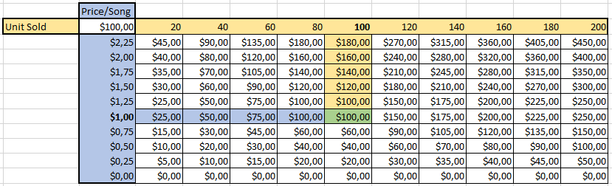

Figure 26: costs with implemented ROI

# Return on Investment

Return on Investments (ROI), according to Whitten and Bentley (2007:425), is a technique that compares the lifetime profitability of alternative solutions. It is calculated by using the formular presented below.

$$ROI= \frac{(Estimated Lifetime Benefit/Gain From Investment – Estimated Lifetime Cost/Cost of Investment)}{Estimated Lifetime Cost/Cost of Investment}$$

The estimated cost of the investment can refer to two possibilities: assets provided by investors and the additional assets that Abstract uses to benefit RIP. The estimated benefits that are gained from an investment refers to the assets generated by an investment made by Abstract or investors.Target investors of RIP includes the artists as well as both large and small scale companies. Artists have been targeted for their embodiment in the nature of RIP, as well as for their contents that serves as the product sold by RIP. Therefore, attracting artists, whether they are small or large-scaled is a critical element for RIP. Content provided by the artists can be converted into monetary values, as their content is assigned to a value, of which RIP receives a share of the sales of each item (at roughly 10%), which ultimately returns a value to the artist and to Abstract.

Regarding the content and the investments made the average price of a song on iTunes is $1, 29. Small-scale artists who works from their homes or create content- part time, shows a massive ROI rate because the expense to create their work was essentially nothing (excluding labour costs, which the price is assigned for), this if Abstract uses the above-mentioned formula, and a song is sold for $1, 00 which the artist initially valued the song at $0, 70, the ROI is calculated as follows:

If artists invest in RIP:

$$\frac{(1,00 – 0,70)}{0,70}=42,8\% Return on Invesment(Per Item Sold)$$

If a large company invests a surge of money into RIP.

*(Assuming RIP sold 100 items for $1,00 and the company invests $1000,00) $$\frac{(100,00 – 1000,00)}{1000,00}=-90,0\% Return on Invesment$$*

With regards to the nature of RIP, since blockchain is a new technology and the estimation of how much RIP will grow is nearly impossible as there is no documentation nor current investors. Therefore, large investments made by companies would be cautious. According to Wiederhold (2017:5), “The value intellectual property is the income it generates over time (Wiederhold, 2017:5)”. Furthermore, Wiederhold (2017:5) states that continuous improvement will result in growth of value overtime. Due to the initial value (which is difficult to estimate for RIP currently because of the lack of information), RIP needed to grow through continuous improvement. When its value reaches a peak, where large investments yield an attractive ROI, RIP can grow exponentially as it can utilise large investments.

# Threats from Emerging Technologies

According to Crouch (2016), blockchain, artificial intelligence (AI), and predictive analysis are considered to be emerging technologies at risk or threatening. These technologies may cause socioeconomic and cultural impacts to the society and to the political environment. It is true that these technologies can create new job opportunities, however, it is also true that these technologies can cause job losses as they require a high-level of knowledge and skill sets. Other threats also include situations where data can be stolen especially when applications such as RIP are connected to a network. One of the more popular technology emerging to the current society is IoT or the Internet of Things; many analysis state that the IoT is a great innovation, yet it is also a great platform for hackers, thus, Abstract suggests that RIP should be strictly used from the computer or from mobile devices only. A simpler and less chaotic threat is spam mails. Spam mails itself can be harmless, but they can be annoying to the users especially when a hacker or malware somehow obtains a user’s contact details and sends potentially dangerous mail contents or consistently annoys them. Smith and Peot (1993:500-506) states that the current development of AI is not as advanced as people assume, thus, it can be predicted that AI will not hinder the RIP applications, and that AI can in actual fact boost the security. With the threats from emerging technologies discussed, it is once again emphasized that RIP uses blockchain technologies, and is strongly secured. Other possible threats towards RIP does not pose a large risk to RIP - as RIP is a high-level application, and in the technological environment, all threats can be combated – of which RIP plans to combat any problems faced in the present and future.

The market analysis was conducted for the project of RIP to find and understand the environment RIP will be entering. Current states, industry definition, target market and statistics, competition and market needs, regulations, risk and sensitivity, return on investment, and the threats from emerging technologies has been scrutinised for the purpose of:

* Understand existing customers
* Identifying potential customers
* To develop effective strategies
* Identify new business opportunities
* To examine and solve the business problem.

Cost/ Benefit Analysis

# Quantified Analysis

The cost benefit analysis (CBA) is a tool used to weigh the projects pros and cons of solutions as well as to determine the economic benefits thereof in order to make financial decisions. The CBA of RIP can be used to: justify the technological equipment invested, determine the most effective method of keep the cost low as possible, quantify hidden costs, and to ensure accountability of the project of RIP.

The following table figure displays the potential costs and expense for the application of RIP for the next 5 years.

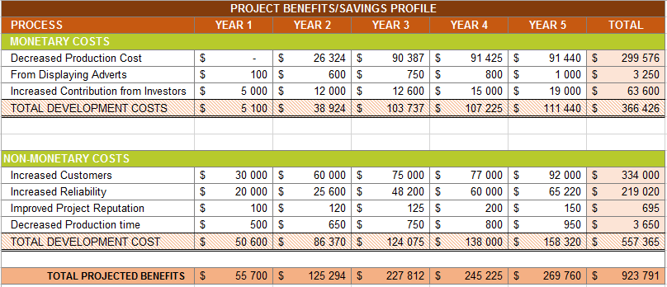

Figure 27: benefits figures

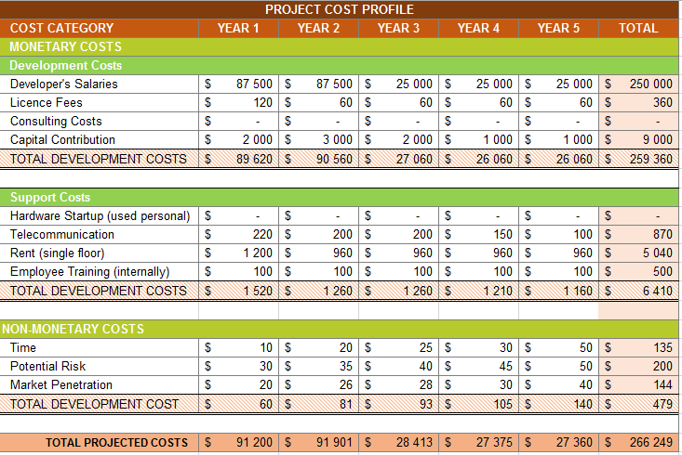

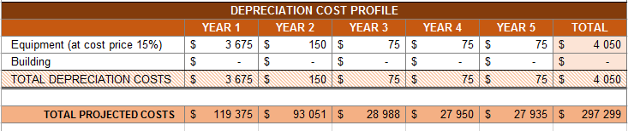

Figure 28: costs figures

With the total costs and benefits calculated, the total profit of the project can be calculated as follows:

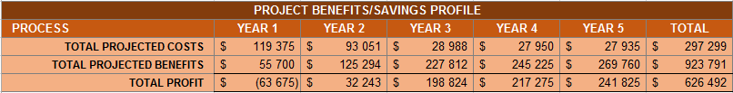

Figure 29: total profits

During the first year, the project may seem to be at a loss, however, it is important to remember that the first year has extra expenses of start-up costs, thus, even though the project may begin with a negative profit, it is strongly suggested that the project has potentials to yield profits incrementing towards the future.

Abstract can justify the technological equipment invested by using personal devices, and not purchasing new devices until equipment have been fully depreciated. Abstract has already kept the costs as low as possible by using trial/ free versions of software as well as using student pro versions. It has been discovered that there are currently no hidden costs as Abstract is new, and the accountability of RIP has been made rigid.

## Net Present Value

Net present values are the values in which one can invest into RIP, and after some years at a certain interest rate, earn back the investments. RIP’s net present value is calculated so that, cash outflow at year 1 = $94 875 (expenses + depreciation) and the discount rate equals to 10%, the net present value equals:

* Year 1 = $ 55 700 * 90% = $ 61 270.00
* Year 2 = $ 125 294 * 90% = $ 112 764,60
* Year 3 = $ 227 812* 90% = $ 205 030.80
* Year 4 = $ 245 225 * 90% = $ 220 702.50
* Year 5 = $ 269 760 * 90% = $ 242 784.00

Therefore, by discounting the future cash flows, the time value money problem is eliminated - resulting in a positive net present value and supporting the recommendation of RIP even stronger.

# Unquantified analysis

Unquantified analysis is analysis conducted to calculate the rate at which a company or project will fail to quantify their benefits (Masur & Posner, 2016:87). In this section of the report, the reasons to why RIP might fail along with the weighted calculations will be discussed. A few potential factors that might yield to a loss in the project consists of: poor productivity rate, poor quality of project, overpayments to developers, theft, and not taking the income opportunities.

If RIP has the probability (from previous data) of:

* 75% Positive environment
* 15% Neutral environment
* 15% Negative environment

And a prediction-probability of:

* 50% Costs and benefits will be fully quantified
* 35% Costs and benefits will be partially quantified
* 10% Costs and benefits will be unquantified from

Using the Bayesian formula indicated below, the unquantified costs and benefits probability can be calculated.

$$P\left(B \right| A)=\frac{P\left(B | A\right)*P(A)}{P\left(B | A\right)*P\left(A\right)+ P\left(B | A^{'}\right)*P(A')}$$

If the three environment has a probability of equally likely (33.33%), the results as follows:

* Given that a it is a neutral environment, the probability equals to:
  + Partially quantified costs and benefits = 12.6%
  + Unquantified costs and benefits = 3.6%
* Given that a it is a negative environment (which has the same probability as the neutral environment), the probability also equals to:
  + Partially quantified costs and benefits = 12.6%
  + Unquantified costs and benefits = 3.6%

Note that the positive environment values with the fully quantified variables are not indicated as it is not part of the unquantified analysis. Through the various calculations, it is clear that at most, the project of RIP will fail at 12.6% which then sums up to the fact that RIP has a success rate of 87,4% at min. Therefore, even though RIP has a potential to fail and yield a loss to the company, it can be suggested that the project and application of RIP can be carried out successfully.

Assessment of Benefits

RIP already possesses various benefits in comparison to doing nothing to solve the problem. As provided in above, RIP has been planned to earn an incremental amount of income from the previous years; which could earn up to $ 626 492 in the fifth financial year. If artists decided to do nothing about their artworks being stolen or constantly being the target of scammer, up to $12.5 billion can be lost every year (Go-gulf, 2011). As amateur or non-professional artists, each income should considered wisely. According to the Music Business World (2014), not only is music piracy causing an issue towards the artists, but also to each countries’ economy. $422 million worth of revenues, $291 million worth of personal income, and $131 million worth of corporate income taxes are lost each year, just in the US. This indicates that a countries GDP has also dropped and many people are not assisting with the cash flow since these people get these music for free.

Along with the financial figures provided above, it is clear that RIP is highly beneficial to implement. The advantages of implementing RIP are the following:

* Artists gets an opportunity to earn an income.
* Boost the GDP of a country
* Increase the economical flow of a country
* No more hassle between intermediaries
* Much trustworthy safer transactions process
* Easy access, easy register platform for artist to publish their works
* Easier tracking of authentic copies
* Investment opportunity of 87.4% success
* A fully legal process

RIP has been dedicated and developed for the artists, however, the benefits of RIP expands to more than just artist, but overall to the economy. Therefore, it can be concluded that RIP’s benefits are socially, economically, and politically accepted and recommend thereof.

Option Appraisal – Recommended Option

Other alternative options artists can make use of to publish their works consists of actions such as:

1. Using a third parties (contractors) to manage artwork distribution
2. Free distribution using websites like 4Shared
3. Using the application of RIP
4. Doing nothing

These options can be summarized and compared as below (viewing it from both the investors’ and mainly from the artists’ views):

|  |  |  |  |  |
| --- | --- | --- | --- | --- |
| **Category** | **1.**  **Use of third-parties** | **2.**  **Free Distribution** | **3.**  **Use RIP** | **4.**  **Do nothing** |
| **Description** | Making contracts with external companies in the industry – professional recorders, distributors, etc. by visiting the company | Using free online software/ websites and distributing art work at no cost using personal computer. | Using the application of RIP (website or mobile application) from personal devices downloaded freely | To do nothing about their produced worked (keep to self) |
| **Advantages** | * Professional assistance provided * Effective marketing * Professional editing to digital artwork * Brand name * Investment opportunities | * Easy access * Free of charge * Widely distributed at a short period of time * Unlimited number of downloads | * Easy access * Safe transactions * Application is free * Can monitor distribution * Widely distributed * Potential scouts from companies * Currently is free of adverts * Confidential data kept secure * Unlimited purchases (not limited per day) * Successful investment opportunities * Copyright protected | * Avoid hassle * No one can criticise about art work |
| **Disadvantages** | * Costs are expensive * Too much hassle * Contracts can be annoying * Overwhelming scale * Investments may not yield positively | * Copyright violated * Adware * Unsafe transactions * Artwork is unknowingly distributed * Websites may not be secure * No investment opportunities | * New and unknown * Have to purchase items | * Wasting opportunity * No publicity * Not worth it |
| **Expense costs** | $ 87 per song sold | $ 0 | $ 0.1 (royalty) per song sold | $ 0 |
| **Income costs** | $ 10 | $ 0 | $ 0.9 | $ 0 |
| **Risks** | * Loss in income * Contract binds * Fraud | * No income * Copyright infringement * No privacy | * No as many users available as freeware | * Losing all opportunities from start |
| **Opportunities** | * Learning experience * Professionalism * Networking with people in the industry * Increased publicity (chance to get famous) | * Increased publicity on the internet * Quick vast distribution | * Networking with people in or interested in the industry * Quick vast distribution * Increased publicity on the internet * Earning an income from a hobby * Experience the professional realm for free | * Spare more time * Spare energy |
| **Requirements (preparations)** | * Money * Prior connection * Appointments * Demo products * Lawyers | * Completed product * Internet connection * PC/ mobile device | * Completed product * Internet connection * PC/ mobile device | * Nothing |
| **Process comfort** | Very uncomfortable | Comfortable | Comfortable | Very comfortable |
| **Process time** | Very long | Medium | Medium | N/A |

Table 3: optional appraisal

It is clear with the table provided, that even with factors of: advantages, disadvantages, expense costs, income costs, risks, opportunities, requirements, process comfort, and process time; of alternative solutions well compared, RIP can be highly the superior for both investors and artist.

Key Assumptions and Dependencies

Abstract is required to make several key assumptions to model the structure of development cycle which Abstract presumes that the following assumptions are true. During several meetings, these assumptions have been discussed to identify risks and deficiencies within the system. Key assumptions have been identified according to the architecture of RIP, historic data from similar project, and group meetings. These are the key assumptions that have been identified:

# Assumptions:

## A fully committed development team:

Abstract will assume that the development team at hand is completely committed to the development and maintenance of RIP. A project can only be successful if it has strong personnel and if the personnel is motivated to fulfil their described roles. Due to RIP’s nature as a digital service, overtime RIP will need to be improved and any erroneous code will need to be fixed.

## Best available development team:

Abstract will assume that the development team is the best available team for RIP and that the team have learnt the necessary technical skills to construct the system. The performance of the development team will reflect from their technical skills to result in the best product.

## RIP service times:

Abstract will assume that: the service is completely functional when customers request for the service, and the service time of the transaction (i.e. the purchase of a song) is a reasonable duration for both parties (long enough to minimise the load on Abstract servers and fast enough to satisfy customer request for the song).

## Flawed system/ System maintenance:

Abstract will assume that the services of RIP is flawed and that there are other sections of RIP that can be improved. End-user license agreements are agreements that contain the restrictions to which a user may use the software that the company provides. RIP works in a similar matter, there will be restrictions to which users may use RIP legally, thereafter, depending on the nature of the violation, a punishment of compensation will be due.

## Accuracy of project schedule:

A time schedule for the development was set out in the first phase of development, thus Abstract will assume that the project will be completed accordingly. The accuracy of the project schedule is important as on specific time stamp, a component must be completed without stalling the development of other components.

## Basic knowledge of the website:

Abstract will assume that customers understand the basic concept of RIP and possesses the basic knowledge of how to make use of RIP’s services. Abstract will assume that artists will invest their work to the website with common knowledge.

# Assumption Prioritization:

This segment of key assumptions and dependencies discusses the priorities of assumptions, the reasons for being a priority, and the impact these assumptions can have if they have been incorrectly prioritised. The priority will be created based on the nature of the assumption and the prospect of that assumption (higher the possibility - the higher its priority), the number of the personnel involved, and the direness of the impact that the assumption can have.

## A fully committed development team:

Out of the assumptions listed, this assumption is the most crucial assumption as a less experienced staff that is motivated to work, can accomplish more than an unmotivated team of experienced workers. Therefore, this assumption rates higher than a team of highly-skilled workers. Other assumptions cannot be made if system does not develop due to uncommitted teammates.

## The best possible development team:

The best possible development team must be prioritized because without a highly skilled team, the service times cannot be optimized and the system design will be crude, thus, the flaws of the system will not be solved. A highly skilled development team will abide by the general user interface rules, and create a system that requires the minimal effort to use and memorize.

## Accuracy of project schedule:

The scheduling of the completion date for each component of RIP cannot be done without a highly skilled and motivated team, however, without this assumption the other assumptions cannot be completed as previously discussed in the above section. Without the punctuality of the development team, certain components completion time will be delayed.

## Flawed system/System maintenance:

The impact this assumption, must not be seen as flawless, however, that the system maintenance has not performed nor that the flaws are have been fixed. This section deals with the prior experience of the team. If system maintenance is not performed, the system will become unattractive to customers and investors, thus rendering RIP completely meaningless.

## RIP service times:

Service times are especially important for the functionality of the RIP application, however, it cannot be prioritised any higher than the above assumptions, because the above-mentioned assumptions deals with the core development of RIP. The remaining assumptions are to be less prioritized because of these assumption dealing with user enjoyment. If service times is not prioritized, users will lose interest in using the service, and ultimately not invest in RIP.

## Basic knowledge of the website:

Basic knowledge of the website is not to be prioritized over the other assumptions as this can be improved through communication with customers through several means (i.e. questionnaires, online interviews, help tickets, and feedback). This is the least prioritized assumption as information gathered is simply done by communication.

# Dependencies:

This segment will discuss the types of dependencies that are within RIP along with its development cycle. Dependencies, in this context, refers to the relationships between each processes, however, the definition of process can be very broad, as it can be processes inside the development, the dependencies between processes of the service provided, and the dependencies between all assumptions. The inability to maintain these relationships or even ensure them, can have severe economic effects on Abstract and its investors. There are four defined categories of dependencies, namely: finish-to-start, start-to-start, finish-to-finish, start-to-finish.

## Finish-to-start dependencies

These types of dependencies require the predecessor process to finish entirely before the successor process can start.

* **Project development**

There are several key components that require another component of the project to be finished before its development can begin. RIP intends to provide an online service through a website or mobile application. A web service had to be developed first. If the development of a component (i.e. the completion of a web service) is delayed by a week, the completion of the successor component (i.e. the website) will also be delayed by a week. The unintentional delay of an entire project can lead to misinformation to investors which can negatively influence the contribution from investors and can also lead to the inflation of song prices to compensate for the financial imbalance.

* **Project planning**

RIP is a complex program that utilizes several different coding languages and difficult concepts. Abstract must fully plan and draft what is intend to be done and how it will be done. Without proper planning, the services provided by Abstract can be worse than anticipated. With a poor service, development costs will be increased, more specifically, the capital contribution since Abstract will need to invest more to improve its product, as well as there will be a significant increase in developer salaries. With an increase in capital contribution, developer salaries, and no increase in sales- the pricing of songs will be inflated along with the revenue percentage that Abstract receives from each individual sale. Before Abstract can start with the construction of RIP, the planning for the entire project was thoroughly completed.

## Start-to-start dependencies

These types of dependencies require the predecessor process to start, before the successor process can start.

* **Skill identification**

The technical skills of the development team need to be assessed and then work can be assigned to each person. The technical skills identified by Abstract will influence the salary that each individual developer earns, however, the assignment of each salary will not have any significant effects on the price of the service. The relationship between these processes fall under the start-to-start category, as Abstract acquires an initial concept of the technical skills of their workforce beforehand, they can start to assign work to each person.

* **Service and Release**

The release of RIP and the utilization of the service provided, has a start-to-start relationship (however, these are not necessarily finite processes). The process of releasing RIP to the public must first begin before any customer can make use of its services.

## **Finish-to-finish dependencies**

These types of dependencies require the predecessor to finish, after which the successor process can finish at any time.

* **Project Development**

Components that require other components to finish first, in this case both can be started and developed, however the successor process can only be finished once the predecessor process completes. An example in RIP, would be the blockchain integration as it can be developed on its own in its own local server, and the web service can also be developed on its own, however, the block chain component can only fully finish once the web service completes.

* **Transactions**

The request to purchase a media online and the processing of online transactions through the servers have a finish-to-finish relationship. Only after a customer requests to purchase media, can the process of the running the transaction through the Abstract server finish.

## Start-to-Finish dependencies

These types of dependencies require the predecessor process to start before the successor process can finish (these types of dependencies are the most uncommon).

* **Transactions**

Customers request to purchase song and then the price of the song is deducted from their current funds. In this dependency it is assumed that the customer has the required funds to purchase the song. When the process of acquiring a requested song has started, can the process of billing a customer for cost of the song begins.

These dependencies are defined as the relationships between processes, nevertheless, this segment only covered processes that are relevant toward RIP’s business structure. Several of these dependencies can have crucial increments to cost or benefits and inflations to the service price of RIP, however some of the above-mentioned processes do not directly affect the cost/ benefits or the inflation rates of the services, and was therefore not mentioned when discussing the specific dependency.

Implementation Considerations

This segment discusses the risks associated with RIP. The POET approach has been used to discuss this segment, as it creates four well defined categories for the risks. The risks that are discussed will be risks that specifically influence the financial projections of RIP, as well as the methods to manage the impact of these risks. Investors and customers are required to understand risks, as a risk can possess an influence on key factors such as sales and percentage revenue.

# POET approach:

## Political

The political factors of risks intend to encompass the interactions between customers, organizations, and the governments as there are several laws and regulations set up by each party to determine the constraints of RIPs services. If RIP becomes a global service, Abstract needs to keep in mind that different countries have different laws regarding to the personal details that Abstract may inquire to an individual; which can influence the information of what RIP can store in its database. There is little that a single organization can do to influence the politics of a country, however, Abstract will attempt to create a compromise standard that meets a global standard.

Another issue about political factors are the fact that there are several countries that have issued a proscription of cryptocurrencies. As cryptocurrency is the only formal method of using RIP’s services, it prohibiting the usage of RIP in these countries. Abstract can for the moment, withdraw its services from these countries until it is available.

## Operational:

Operational factors deal with the processes within a business and how well these processes solve the problems identified by the business. Operational factors often include large components of a business such as the infrastructure, database, and several other factors that RIP is composed of. As RIP grows, its current facilities will be inadequate for dealing with the larger data. If the user base becomes too large and there are too many requests for the current servers, it can negatively affect the interest and ability of users to use RIP’s services. As RIP grows, Abstract needs to acquire specialized technicians to facilitate the processes of RIP.

A core risk of RIP, is its blockchain component as it is a fairly new technology and there is limited documentation of blockchaining, the limitations of blockchain cannot be explored. This means that there is an unknown aspect to the regarding secureness of data. Abstract however, keeps itself updated with blockchain technologies and ensures that any recently documented errors in blockchain can be compensated for. Loss of data or exposure of the system can lead to a major loss in value of RIP’s cryptocurrency value, and/or loss in overall capital. Abstract also makes use of traditional network security - to provide an additional layer of protection against the misappropriation of data.

## Economic/Financial:

Economic factors often deal the cost/benefit analysis of an organization. Economic factors measure the effectiveness of a system. These factors often influence what decision are made regarding the further development of a system. An issue that can arise is the ability RIP to fairly compensate a customer for using its service. If a customer requests a specific amount of the cryptocurrency for RIP, and it does not have the ability to compensate it, the customer becomes the reason to a financial error in the system. RIP uses a Meta mask, and then converts the popular cryptocurrency to its own, however, if transfer rates were to change, the speed of which RIP adapts to these rates will influence if RIP can compensate customers. The inability for a system to provide appropriate service to customers can lead to major loss in the usage of a service and in extreme cases, handled via the law. A hypothetical solution could be to create a monitor that according adjust the rates real time, more realistically a monthly or weekly check can be done to adjust the price of RIPs cryptocurrency.

## Technical:

The technical factors of a system, are described as the factors that influence a systems’ ability to satisfy the requirements. An organization describes a problem, and then evaluates if they have the available technological resources to create a system that can provide a solution to this problem. A potential risk is Abstracts ability to maintain servers, due to the fact that Abstract does not have any initial capital and must maintain servers without funding. If servers are not available, long term funding such as income from sales become unavailable as well. To reduce the impact of this issue, Abstract may look towards technological shortcuts such as splitting data between different domains. Another technical factor is the availability and ability of technicians. If Abstract were to encounter a flaw in the system, it requires adequate technicians that can create a solution for this flaw in as little time as possible. Abstract can compensate for this factor by periodically performing performance reviews to ensure that the technicians are adequate.

# Concepts to understand before investing:

Organizations and customers that intend to invest in RIP have several concepts that must understood before investing any type of resource into RIP. Firstly, RIP was created as a university project and is not at a commercial level, therefore, it can have several components that are erroneous, however, RIP has an endless room to grow and improve. Other concepts include the fact that the technology used to create RIP is fairly new, thus there is little documentation and the limits of these technologies are not well defined. This could ultimately lead to major errors or major developments in RIP.

Resource Requirements And Cost

In the beginning of the development of RIP, resources such as funds, equipment’s, and labour were needed. There are two types of resources namely: external and internal. External resources are the resources outsourced (resources needed from outside the company), which includes: software licence fees, external labour fees, service fees, etc. Internal resources are resources needed within the company which includes access to technology, salary, etc. The following table displays the financial figures that were needed to develop RIP, it is important to keep in mind that Abstract members started as a small scale business, with minimalistic resource needs which has been mostly sustained and provided personally.

|  |  |  |  |
| --- | --- | --- | --- |
| **Resource requirements  and costs:** | **Investment (average)** | **Capital (total)** | **Running costs per annum (range)** |
| External costs | $ 4 500 | $ 5 000 | $ 3 520 – 5 000 |
| Internal costs | $ 5 620 | $ 1 200 | $ 1 250 – 3 500 |
| **Total** | $ 10 120 | $ 6 20 | $ 4 770 – 8 500 |

Table 4: resource requirement and costs summary

An office space, office furniture’s, external programming software licence, and internal labour were the most main resources that were needed for the development of RIP. Abstract has managed to continuously grow and develop the application of RIP from this start-up figure.

Funding Source/ Timing/ Certainty

This segment of the document discusses the: funding sources, timing, and certainty of the funding. Funding of a project is crucial for its inception and its extended existence. Regarding RIP, because of its initial status as a university project there was no funding other than time and work. Thus, the project was started knowing that there would be no funding plan to subsidize the planning and development of RIP. During the release of RIP, funding was required for its extended existence. There are several types of funding that a project required, or was suggested. Even after the several funding sources have been identified, their certainty was not necessarily secured. For a project to exist it requires long-term and short-term funding.

# Short-Term Funding

Short term funding is the act of seeking monetary funds that is used and repaid within a short period of time (usually a year but may vary from organization to organization).

## Overdrafts

An overdraft occurs when capital is drawn from a bank account and the balance becomes a negative. Abstract has come to an agreement with a bank and another investor to fund the project, as that Abstract may cause an overdraft in the first financial year. The timing for that Abstract might need these funds can be at any given moment, however, there is a high certainty that Abstract can acquire funds in various manners as it has been either previously arranged with the necessary parties. In extreme cases, even if the overdraft limit has been met, acquiring funds is still possible, but follow a consequence of additional fees.

## Loans

Loans are another method of acquiring short term funding, loans however have a higher rate of interest, and they are less flexible as the loan is entirely predefined. Loans can be made fairly quickly, however their certainty relies entirely on the credibility of the business and the amount that is requested to be loaned.

# Long-Term Funding

Long term funding is the act of seeking monetary funds that is to be used and repaid within an extended period of time which usually for spans for longer than 5 years, and can vary from organization to organization.

## Business Angels/Investors

Business Angels or Investors are investors that informally invest into a business usually in exchange for equity stake or a place on the board. Abstract can accept investments because RIP is a university project and placing a business invest in the project in exchange for a board member that has experience with the business architecture will be a beneficial trade. The timing of these can be very aberrant, arriving at unprecedented times, however, they often arrive when a product shows a certain level of promise, therefore, Abstract can expect private investors to arrive at peak performance points of RIP. As for certainty, as previously discussed these investors arrive at random and it is uncertain if they will arrive or not.

## Retained Profits

Profits made from the revenue percentage of each product sold and other methods (i.e. advertising) are initially distributed to shareholders to pay them for their investments. However, not all profits are distributed; and Abstract will retain a share of its profits, which will be use to satiate its requirements to the future needs. The timing for retained profits can rather be explained as an overtime process depending on Abstract’s certainty that RIP will be a success.

Timescale

The timescale consists of milestone actives for the application of RIP. These activities entails future goals for RIP and the timing (start and end date) of it. Note that no specific dates have been indicated as all goals are aimed to the future, thus, one cannot be exactly sure due to unexpected obstacles.

|  |  |  |
| --- | --- | --- |
| **Main milestones and dates:** | **Proposed start:** | **Proposed end:** |
| Complete application | August-2017 | October-2017 |
| Service Integration (Service to purchase media) | August-2017 | October-2017 |
| Increase in user base and investors (at least 100% increase) | October-2017 | December-2018 |
| Value increment of Abstract crypto currency (at least 100%) | October -2017 | December-2018 |
| Increase in stock (available songs in database) by 100% | October -2017 | December-2017 |

Table 5: timescale with milestones

Abstract aims to accomplish these goals with the purpose to make the application much more satisfactory for the users.

Comments/ Issues

RIP has been design to meet that needs of users and to support these users at all circumstances. Users must remember that RIP is an online application, thus internet access is required - else there will be issues with the functionality. Using RIP on other OS other than the stated ones might also cause functionality issues. All software developed can and will crash at one point while running the application, when the application (either web or app) crashes, just simply restart the application and if there has been any issues caused due to the crash, contact Abstract immediately.

RIP is still under the early stages of implementation, therefore users should know that the application may not be rigid in some areas. However, Abstract will deal with issues encountered and fix problems as soon as possible.

Results and Findings

It was found that through an alpha and beta tests of RIP, many users were unaware of the fact that they were consistently violating copyrights. Many users were also computer illiterate, however, dude to the rapid increased usage of smart devices and a user-friendly GUI, many users seemed to use the application with ease. Is was also found that 70% of the users were male, and 30% of the users were female. Furthermore, 60% of the users were hobbyists whereby the rest consisted of amateur artists, investors, and normal users. By using these demographics, it is possible to adjust the application towards the trends at a later stage of implementation. Other finding showed that users wanted the full version of the mobile application and mobile applications for iOS. Ultimately, results have showed that users were satisfied with the application and understood the implementation reasons for RIP which lead to 77% of artists and 40% of normal users (normal users still craved for the free access of files) recommending RIP to fellow colleges, friends, and families.

Conclusions and Recommendations

It is clear that with the provided calculations, evidence, and studies that RIP is a great application with wide-spreading opportunities. Abstract has complied this business case to convince the users, potential investors, and people in the industry for the continuation of the financial assistance as well as the maintenance and implementation of RIP. The core purpose of this project was to provide the artists with a safe yet easy-to-access platform to sell their music pieces. Facts such as risks has been scrutinised in three categories namely: popularity, monetary worth, and competitions. The ROI resulted to 42.8% and although RIP yields a loss in the first financial year, from the second financial year, RIP yields a profit which increases though the future years. Through the option appraisal which has compared all alternative solutions, it has been found that RIP should strongly be implemented and made use of. Minor issues have been encountered during the beta testing stages and along with the results and findings of RIP, issues and better implementations has been added and solved accordingly.

Bibliography

Crouch, G.W. 2016. Top 4 Threats to Emerging Technologies in 2017, *Linkedin.* 16 Dec. https://www.linkedin.com/pulse/top-4-threats-emerging-technologies-2017-giles-w-crouch Date of Access: 10 Oct 2017.

Jobs, S. 2007. Thoughts on Music. <http://www.immagic.com/eLibrary/SOURCE/APPLE_US/A070206J.doc> Date of access: 5 Oct 2017.

GO-Gulf. 2011. Online Piracy In Numbers – Facts and Statistics. https://www.go-gulf.com/blog/online-piracy/ Date of Access: 7 Oct. 2017.

Masur, J.S. and Posner, E.A. 2016. Unquantified Benefits and the Problem of Regulation under Certainty, *Cornell L. Rev.* (2):87.

Music Business Worldwide. 2017. Why does the RIAA hate torrent sites so much? *Music Business Worldwide*. 6 Dec. https://www.musicbusinessworldwide.com/why-does-the-riaa-hate-torrent-sites-so-much/ Date of access: 17 Oct 2017.

Pannell, D.J. 2017. Sensitivity analysis: strategies, methods, concepts, examples. http://dpannell.fnas.uwa.edu.au/dpap971f.htm Date of access: 6 Oct 2017.

Smith, D.E. and Peot, M.A. 1993. Postponing threats in partial-order planning, *Proceedings of the eleventh national conference on Artificial intelligence*. 500-506.

South Africa. 1978. Copyright Act 98 of 1978.

Stantchev, V., Colomo-Palacios, R., Soto-Acosta, P. and Misra, S. 2014. Learning management systems and cloud file hosting services: A study on students’ acceptance, *Computers in Human Behavior.* 31(1)612-619.

Whitten, J.L. & Bentley, L.D. 2007. Systems Analysis and Design Methods. 7th Ed. New York, NY: McGraw-Hill Irwin.

Wiederhold, G. 2007. What is Your Software Worth? *Comm. Of the ACM.* 49(9):1-40.

Writer, S. 2016. How much money you need to be middle class in South Africa, *BusinessTech.* 3 Feb. https://businesstech.co.za/news/wealth/111285/how-much-money-you-need-to-be-middle-class-in-south-africa/ Date of Access: 6 Oct. 2017

**Part C**

**Appendix**

This section is a separate section to both the technical report and business case documentations. This section has been complied solely for the purpose of Abstract’s group evaluation, analysis, and regrets made throughout the process of the development of RIP.

* + - 1. 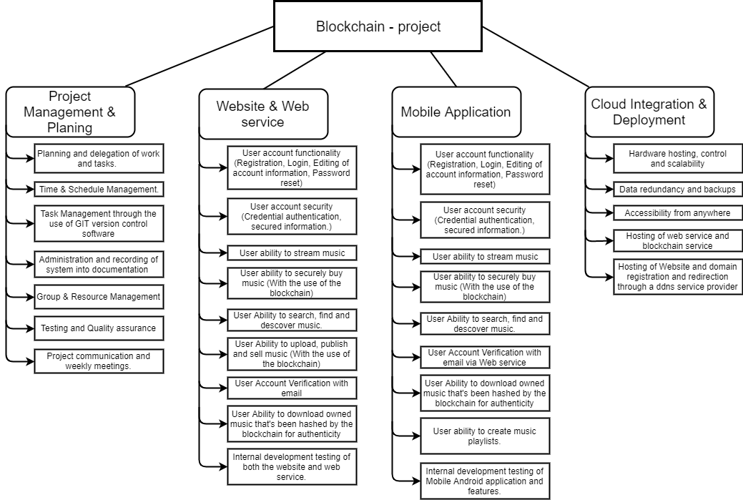Work Breakdown Structure

Figure 30: work breakdown structure

This work breakdown structure displays the work the group had to accomplish categorised into different to features. The group split the tasks into pairs and groups.

* + - 1. Use of Git and Slack to facilitate group development:

The group used Git in the git-flow configuration as the version control software. The git-flow structure provided the group with a tree structure containing several branches. The master branch is where the current live version of the group’s software is located. The develop branch is used to keep track of any new developments which was furthermore divided into a few sub-branches. The group used: the feature sub-branches to keep track of the individual features of our project, such as the website, web service, mobile application, database, blockchain services, etc. Once a feature was finished, it is deployed into the development branch for internal testing. After internal testing and ensuring there are no bugs it is the pulled into the master branch for live deployment. The group used Slack primarily for scheduling meetings with the demi and asking important questions to the lecturer. It is important to note that group used mainly used Discord as a communication tool as Discord provide the utmost comforting online group chat system.

# Benefit/Challenges of Git and Slack:

Git allowed for easy management of source code. It also served as a backup of our source code and history to reference for changes that were made. It made working on the same features simultaneously easy. It helped with project management to make sure everyone was doing their work and staying on track. Challenges with using git came in the form few technical problems and merge errors. There were minor learning curves to getting started with git and adjusting to using it proactively. Benefits of Slack included the fact that it could easily keep track of commits on git and was intuitive to use for setting up meetings. Challenge faced consisted of the fact that Slack does not support VoIP- a key feature to group work and almost was a deal breaker for some. The group mostly moved over to using similar programs to Slack that also supported VoIP called Discord.

# Should it be a requirement next year?

Yes, the group to somewhat content believes that the use of Git and Slack are required for facilitating proper group development. However, it may also seem like member X has been working on a task along which member Y was helping alongside. It makes monitoring and keeping track of everyone easy and a source of valid evidence for dismissing a group member that does not do their work. Slack is a great tool for quick and instant communication between group members, demi and the lecturer. Slack also pairs with Git to track the latest commit letting everyone in the group know what you are up to.

# Tools/technologies that we believe should be used in this module.

The group believes that the current set of tools is sufficient. As a suggestion, the use of Discord is great it is a free application with similar features to slack but also includes VoIP for voice meetings at any given time. Discord also allows you to screen share so that a group member can show their computer screen if they need help or feedback from other group members.

* + - 1. Self-review:

# What did the group learn in this development project?

## Technical**:**

The group had to learn many new technical skills. Starting with the use and understanding of Git and Slack, the industry standard in communication, and effective collaboration. Members of the group were required to learn the programming languages required for creation websites and web services such Node.js, Angular4, JavaScript. The group also had to learn how to develop a Mobile application using Android Studio. The technical skills of creating and using blockchain services such as Truffle, etc. and linking these services to the remotely hosted database’s, and using AWS for cloud migration and hosting of the website and backend services were all self-learnt.

## Non-technical:

Most importantly the group learned how to function as one group. The group learned how to plan properly, how to follow strict conduct and procedure, and how to manage time and resources to the maximum potential. The group also improved communication skills.

# What development methodology did the group use?

The group made use of the Rapid-application development (RAD) strategy. It was effective and gave the group the opportunity to be agile in development – by quickly building a prototype and testing then adding more factuality as needed. It helped the group see the progresses that were made more clearly and allowed the group to make changes easily and at any time. The group would not have recommended any other development methodology as it was easier for all group members to work with a highly agile and flexible strategy.

# How did the experience affect the way of approach development projects in the future?

The group has learnt that the following strategies could have made a more successful approach:

* Be professional, follow the correct conduct and procedures.
* Plan out projects more thoroughly and investigate solutions to the problem in depth.
* Rather be proactive and understanding of problems before making hasty decisions.
  + - 1. Product evaluation:

# What are the best characteristics?

RIP is a user-friendly, easy-to-understand, and creates an extremely intuitive experience. It can steam music as good as any other music streaming web site in the market. RIP provides a dynamic search with live music search results and provides suggestions. It has the ability to easily buy and download music that has been hashed by the blockchain technologies as well as pertains the ability to upload, publish, and sell music thereof. Users can dynamically determine the top listened music and build up a mobile playlists on the mobile app. RIP uses smart contracts and crypto currency to buy a currency form that is used to buy music.

# Given more time, what would we improve?

The group would like to expand the scope of the project beyond just music but to any digital media. This would allow for a much wider audience and better use of the technology. Polish the user interface and make it completely fluid with transmission animations. Optimize the code running on the android app to use as little of the available resources as possible. Implementation of a completely custom blockchain to authenticate any digital media. Optimizing the website and mobile app.

# How effective is it in solving the problem identified initially?

It is effective at solving the problem as the music is linked to a blockchain that is used to identify its authenticity and owner of it. It allows for the real possibility of eliminating piracy and copyright infringements.

------- END ------